Exercise 7: Working with tax units (DefTU)
Altering eligibility to child benefit using tax units (DefTU)

Objectives
We will analyse the distributional and budgetary effects of limiting child benefit to families with children up to 13 years of age. We will implement this reform by creating a new tax unit for analysis.

Directions
- Open UKMOD and access the UK policy descriptions.
- Copy the UK_2026 system and call the copy UK_2026_ex7.
- Create a new assessment unit by copying the definition of tu_bu_uk
- Modify the new assessment unit to reflect the upper limit of age 13 for dependent children.
- Modify the definition of the child benefit policy to include the new assessment unit.
- Save the model changes.
- Run both UK_2026 and UK_2026_ex7.
- Use the Statistics Presenter’s Baseline/Reform template to analyse effects of the reform.

Exercise 7: Working with tax units (DefTU)
Step-by-step solutions and further information

Step 1: Add a new system
This step is the same as for Exercise 1 – see the notes to that exercise for extended details.
- Open the UK model, by clicking on the UK country flag.
- To work more easily with the UK_2026 system, limit the display by right-clicking on the system name (UK_2026), selecting move to hidden system box and then selecting all systems but selected.
- Right-click the system heading (UK_2026) and select the option copy/paste system, entering the new system name UK_2026_ex7.
- Access the search and replace tool by pressing Ctrl+F to find the policy bch_uk.

Step 2: Implement the desired reform
NOTE: You should analyse the existing description of policy bch_uk before attempting to alter it.
- Note that the unit for the child benefit policy bch_uk is tu_bu_uk.
- Navigate to the top right cell of the EUROMOD display (Ctrl+Home).
- Use the search tool to find the TUDef_uk policy.
- Find the DefTu function that defines benefit units in the model (row 9.4).
- Copy and paste this function to provide a useful starting point.
  - Right-click on the DefTu to access the copy and paste menu.

Figure 1: Copying and pasting the DefTu function
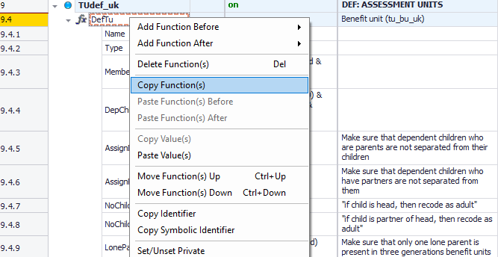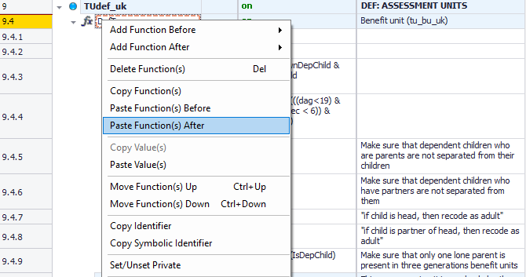

- Turn the new DefTu function off for all systems other than UK_2026_ex7.
  - NOTE: The new DefTu function should be set to n/a for hidden systems by default.
- Enter tu_bunew_uk in the Name parameter of the new DefTu function in the UK_2026_ex7 system.
- Alter the DepChildCond parameter of the new DefTu function in the UK_2026_ex7 system to match our target reform.
- Alter the Comment column of the new DefTu function to avoid possible confusion.
- Navigate to the bch_uk policy and amend the BenCalc function to reference the new tax unit tu_bunew_uk.
  - You may need to use the scroll-bar on the drop-down menu.

Figure 2: Defining a new tax unit
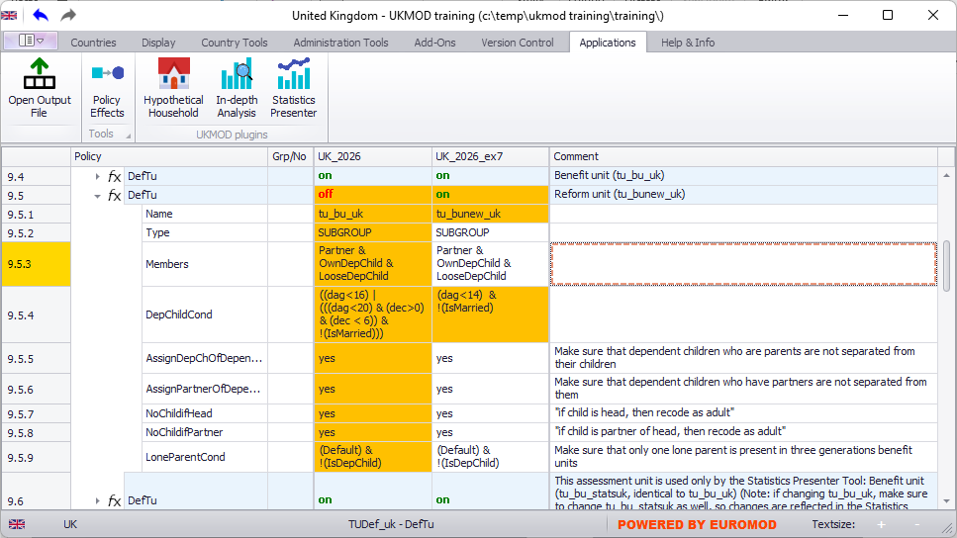
Figure 3: Altering the tax unit assumed for policy bch_uk
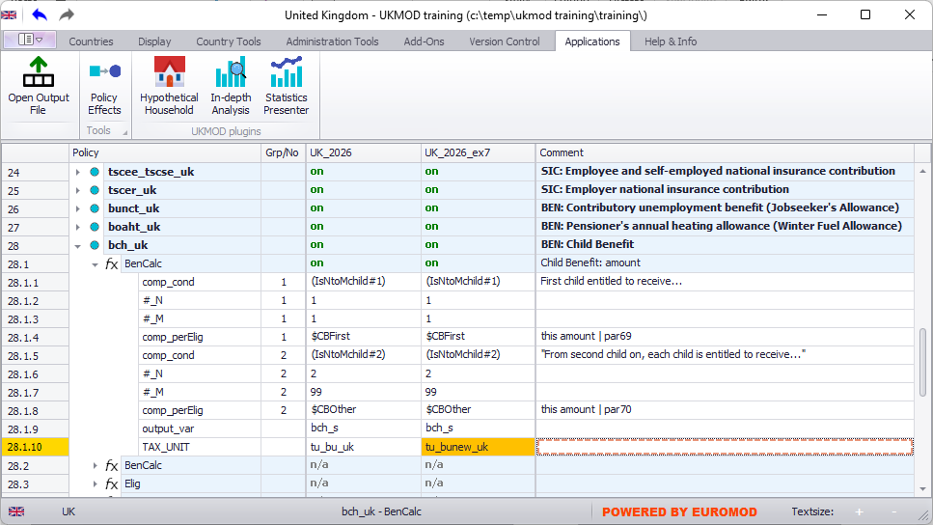

Step 3: Run the model and analyse the output
This step is similar to Exercise 2 – see the notes to that exercise for extended details.
- Save the model.
- Run the model for the two systems of interest (UK_2026 and UK_2026_ex7).
  - Remember to change the Dataset to training_data.
- Start the Statistics Presenter and select the Baseline/Reform template.
- Select output data to assume for the baseline and alternative scenarios.
- Inspect the results.
Figure 3: Inspect the results
