Exercise 6: Working with income lists (DefIl)
Modifying the benefit cap using benefit lists (DefIl)

Objectives
We will analyse the distributional and budgetary effects of excluding child benefit from the benefits cap.

Directions
- Open UKMOD and access the UK policy descriptions.
- Copy the UK_2026 system and call the copy UK_2026_ex6.
- Analyse existing simulation of the benefit cap.
- Identify the income list used to evaluate benefits subject to the benefit cap.
- Alter the income list to omit child benefit.
- Save the model changes.
- Run both UK_2026 and UK_2026_ex6.
- Use the Statistics Presenter’s Baseline/Reform template to analyse effects of the reform.

Exercise 6: Working with income lists (DefIl)
Step-by-step solutions and further information

Step 1: Add a new system
This step is the same as for Exercise 1 – see the notes to that exercise for extended details.
- Open the UK model, by clicking on the UK country flag.
- To work more easily with the UK_2026 system, limit the display by right-clicking on the system name (UK_2026), selecting move to hidden system box and then selecting all systems but selected.
- Right-click the system heading (UK_2026) and select the option copy/paste system, entering the new system name UK_2026_ex6.

Step 2: Analyse the bcap_uk policy
- Access the search tool by pressing Ctrl+F to find the policy bcap_uk.
  - You could also search for all instances of “benefit cap”, which would indicate relevant components via text under the Comment column.
- Expand the bcap_uk policy by double clicking on it.
Figure 1: The bcap_uk policy
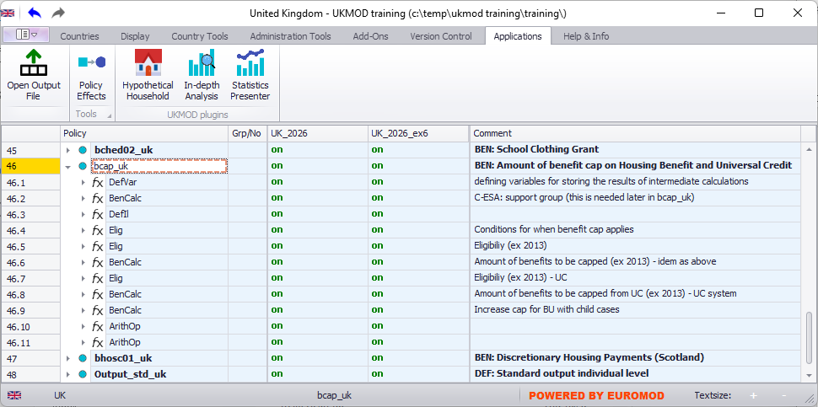

Explore the policy to consider what functions are used, how they relate to one another, which income list(s) are used, which benefits are affected, what is the tax unit for analysis, what variables are generated, etc. Refer to the comment column to gain a quick appreciation for what each of the policy’s components do.

Step 3: Implement the desired reform
We will implement the reform via the income list that aggregates the benefits subject to the benefit cap (il_bencap).
- Navigate to the top right cell of the EUROMOD display (Ctrl+Home).
- Open the search tool and find references for il_bencap.
Figure 2: Components of the il_bencap income list
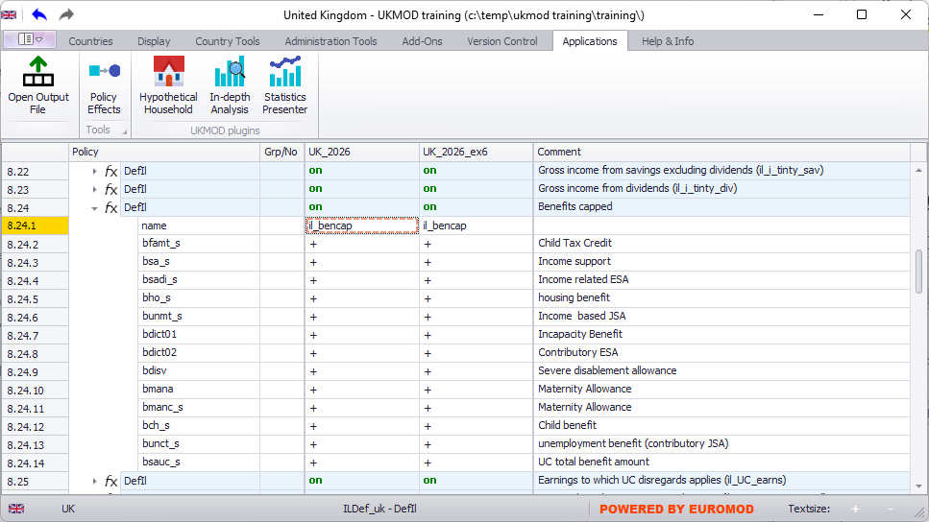

- Note that Child benefit is included in the comment column under the list of Benefits capped, defined by variable bch_s (as in Exercises 2, 3 and 4).
- Adjacent to bch_s (row 8.24.12), under the UK_2026_ex6 system, replace + with n/a.

Step 4: Run the model and analyse the output
This step is similar to Exercise 2 – see the notes to that exercise for extended details.
- Save the model.
- Run the model for the two systems of interest (UK_2026 and UK_2026_ex6).
  - Remember to change the Dataset to training_data.
- Start the Statistics Presenter and select the Baseline/Reform template.
- Select output data to assume for the baseline and alternative scenarios.
- Inspect the results.
Figure 3a: Inspect the results
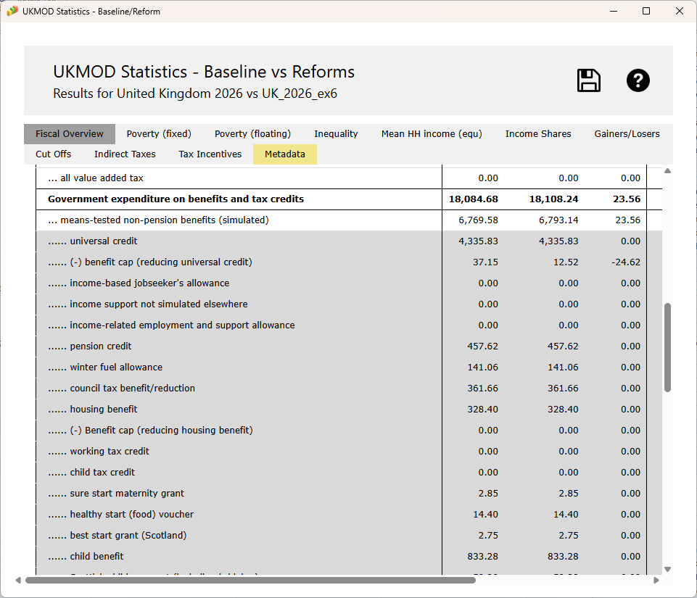

Figure 3b: Inspect the results
