Exercise 5: *SchedCalc* and *DefConst* functions

An income tax reform using *SchedCalc* and *DefConst*

# Objectives

Use the *SchedCalc* and *DefConst* functions to modify the income taxes applicable to non-savings non-dividend income in Scotland in 2026.

* The higher rate of 42% is applied to annual income up to £90,000;
* The additional rate of 47% is applied to annual income between £90,001 and £125,140;
* A new top rate of 50% is applied to annual income above £125,140.
* Analyse effects of the reform.

# Directions

We will implement the new reform by adapting the existing tax policy (*tin_uk*) in UKMOD and use the Statistics Presenter to analyse the associated effects.

* Open UKMOD and access the UK policy descriptions.
* Copy the *UK_2026* system and call the copy *UK_2026_ex5*.
* Open the income tax policy (*tin_uk*).
* Find the *SchedCalc* function applied to non-savings non-dividend income in Scotland.
  + Extend this to accommodate an additional tax band.
  + Use new model constants to control application of the new tax band.
* Find where the constants controlling application of existing tax bands are defined in the model spine.
  + Add new constants introduced in the preceding step.
  + Alter constants to reflect the target policy reform.
* Save the model changes.
* Run both *UK_2026* and *UK_2026_ex5*.
* Use the Statistics Presenter’s *Baseline/Reform* template to analyse the distributional effects.

Exercise 5: *SchedCalc* and *DefConst* functions

Step-by-step solutions and further information

# Step 1: Add a new system

*This step is the same as for Exercise 1 – see the notes to that exercise for extended details.*

* Open the UK model, by clicking on the UK country flag.
* To work more easily with the *UK_2026* system, limit the display by right-clicking on the system name (*UK_2026*), selecting *move to hidden system box* and then selecting *all systems but selected*.
* Right-click the system heading (*UK_2026*) and select the option *copy/paste system*, entering the new system name *UK_2026_ex5*.

# Step 2: Analyse the *tin_uk* policy

* Access the search and replace tool by pressing Ctrl+F to find the policy *tin_uk*.
* Expand the *tin_uk* policy by double-clicking on the policy or selecting the right arrow adjacent to the policy.
  + It is also possible to expand all elements of the policy by right-click *tin_uk* and selecting *Expand All Functions*.

Figure 1: The tin_uk policy

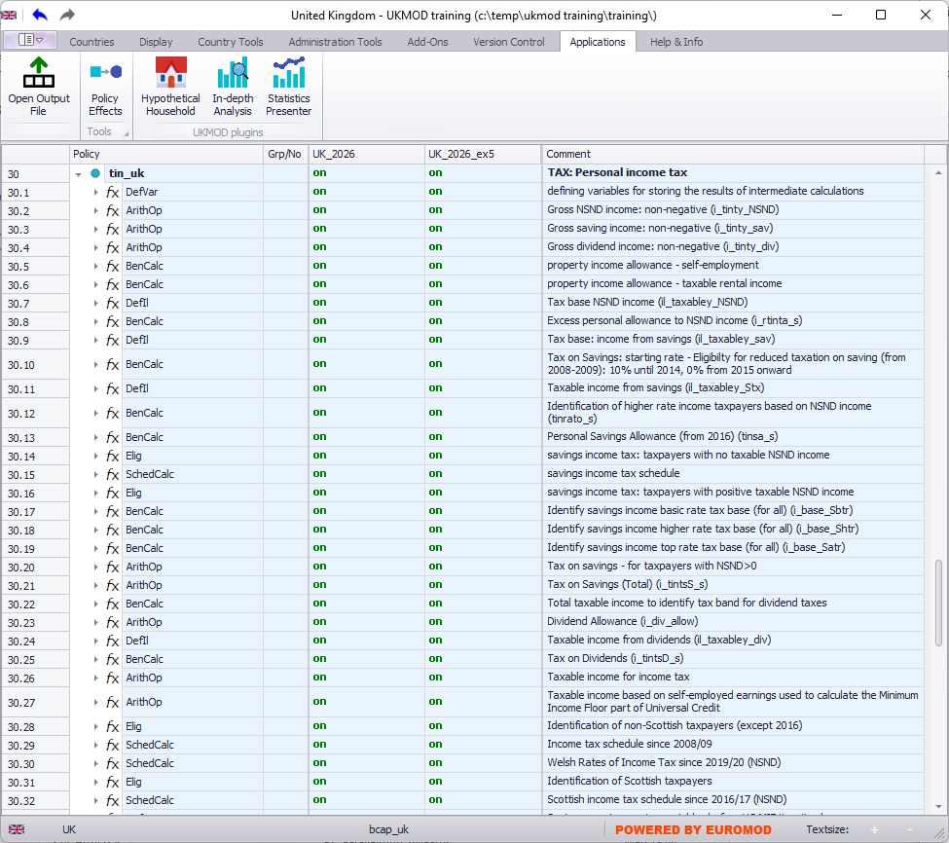

The *tin_uk* policy is lengthy, dealing with differences in the taxation of income from savings, dividends and earnings, and across UK countries (Scotland, Wales, and the rest of the UK). It draws upon income lists (variables preceded by *il_*) and includes a large number of intermediate variables (preceded by *i_*). A summary of provisions for income taxes in UKMOD can be found in the Country Report, which is provided in the documents folder and can be found online at <https://www.microsimulation.ac.uk/ukmod/resources>.

* Find the *Elig* function of the *tin_uk* policy with the comment “Identification of non-Scottish taxpayers (except 2016)”
* Income taxes on non-savings non-dividend income (*il_Taxabley_NSND*) are evaluated by the following three *SchedCalc* functions, with regional differences reflected using the associated *Elig* functions.
* Explore how these calculations work.

# Step 3: Implement the desired reform

We need to add a new tax band to the *SchedCalc* function applicable for Scotland. We will use new parameters to control the rates and thresholds applicable to the new tax band. We will start by adding in the new tax band, before setting the parameters that control application of this band.

## Adding a new tax band to *SchedCalc*

* Find the *SchedCalc* function associated with the comment “Scottish income tax schedule since 2016/17 (NSND)”.
  + This function is applicable to individuals who are in Scotland, as indicated by the immediately preceding *Elig* function
    - *drgn1* is a regional identifier, with value 12 for Scotland
    - See the DRD Excel file in the model’s input folder for input variable definitions.
* Right-click the *SchedCalc* function, and select *Show Add Parameter Form*.
  + Can also be done by selecting *SchedCalc* and pressing Ctrl+A.
* Select *Band_Rate* and *Band_UpLim* and press the *Add* button.

Figure 2: Adding a new tax band to SchedCalc

The new parameters are added to the end of the *SchedCalc* function. As noted in previous exercises, the order of the parameters within a function is not important. Nevertheless, it is good practice to adjust the order of parameters if doing so helps to clarify the function.

* Move the new *Band_UpLim* parameter under the last *band_rate* in group 5 followed by the new *Band_Rate*.
  + These parameters can be moved by dragging and dropping.

Note that the group numbers supplied by default for the new parameters break the pattern of the original set of parameters. This is one advantage of organising function parameters in the model.

* Change the group number of the new *Band_UpLim* parameter from 6 to 5.
* Enter a new constant name *$ITThresh5* to the new *Band_UpLim* parameter of the *UK_2026_ex5* system.
  + Recall that constants in UKMOD are indicated by a *$*.
* Enter a new constant name *$ITRate6* to the new *Band_Rate* parameter of the *UK_2026_ex5* system.
  + Optional: Good practice involves adding associated comments for code that you anticipate returning to at some future date.

Figure 3: Adjusted SchedCalc function

## Set model constants in *DefConst*

We will define the new constants in a way that is consistent with the existing model structure.

* Select the top right-hand cell in the EUROMOD display.
  + This can be done quickly via Ctrl+Home
* Access the search and replace tool by pressing Ctrl+F to find *ITThresh1*.
* Inspect the code defined here, which provides default values for income tax rates and thresholds and adjusts these values for alternative regions.
  + Group 1 is used to identify Scottish rates and thresholds and group 2 Welsh rates and thresholds.
  + If the conditions for more than one group are satisfied by any micro-unit, then the condition with the largest group number applies.
    - e.g. A Scottish resident will satisfy both the default condition (no group number, implicitly 0), and the regional condition defined at 3.4.34 (group number 1), and will consequently be allocated the values defined in group 1.
* Right-click the *DefConst* function, and select *Show Add Parameter Form*.
* Select *[Placeholder]* and press the *Add* button
* Move the new parameter under the first instance of *$ITThresh4* (3.4.14)
* Name the new parameter *$ITThresh5*
* Repeat to add *$ITRate6* just after *$ITRate5* (3.4.20).
  + These first two parameters are added as default values for non-Scottish residents. They are not actually needed, as these parameters will not be used for non-Scottish residents. Nevertheless, it is good practice to include default parameter values, and omitting them will cause the model to generate a warning message (you can test this for yourself).
  + *$IThresh5* just after *$ITThresh4* (3.4.42) and set group to 1.
  + *$ITRate6* just after *$ITRate5* (3.4.48) and set group to 1.
* In the *UK_2026_ex5* system, set the following values:
  + (3.4.14) *$ITThresh5* 0
  + (3.4.20) *$ITRate6* 0
  + (3.4.41) *$ITThresh4* 90000#y
  + (3.4.42) *$ITThresh5* 125140#y
  + (3.4.48) *$ITRate6* 0.5

Figure 4: Revised DefConst function

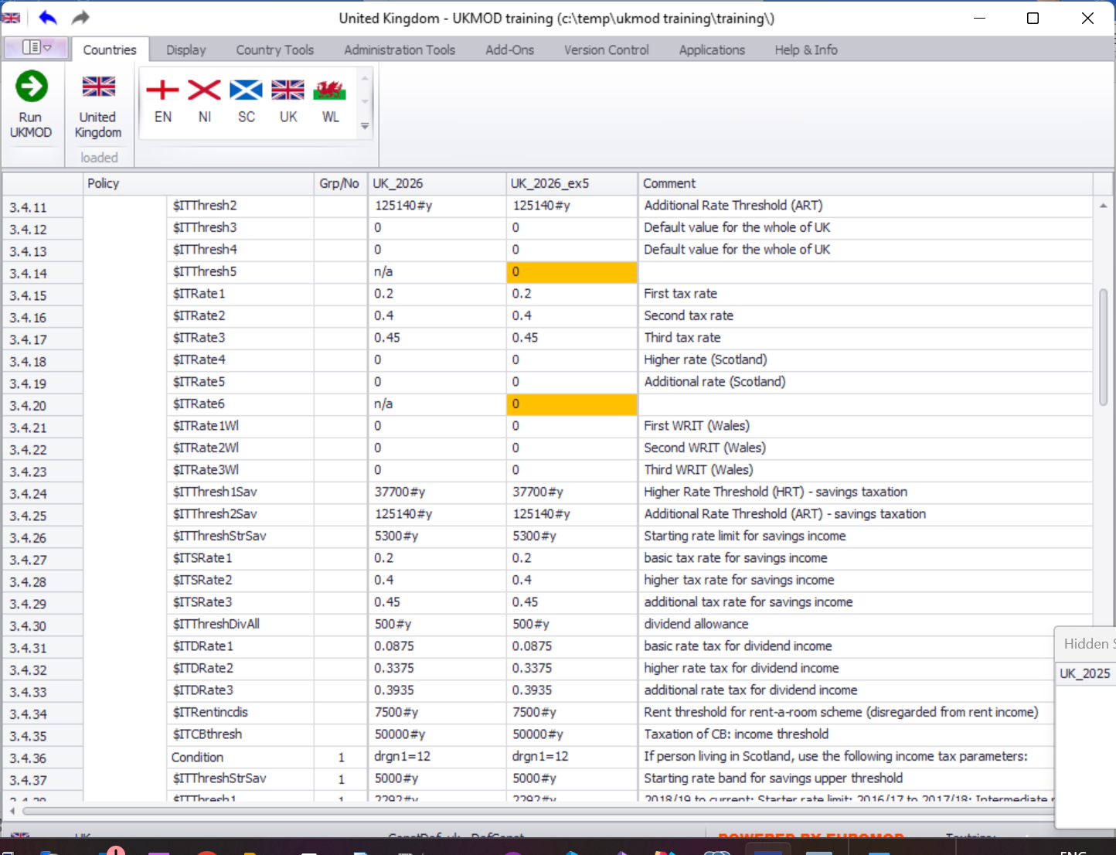

…

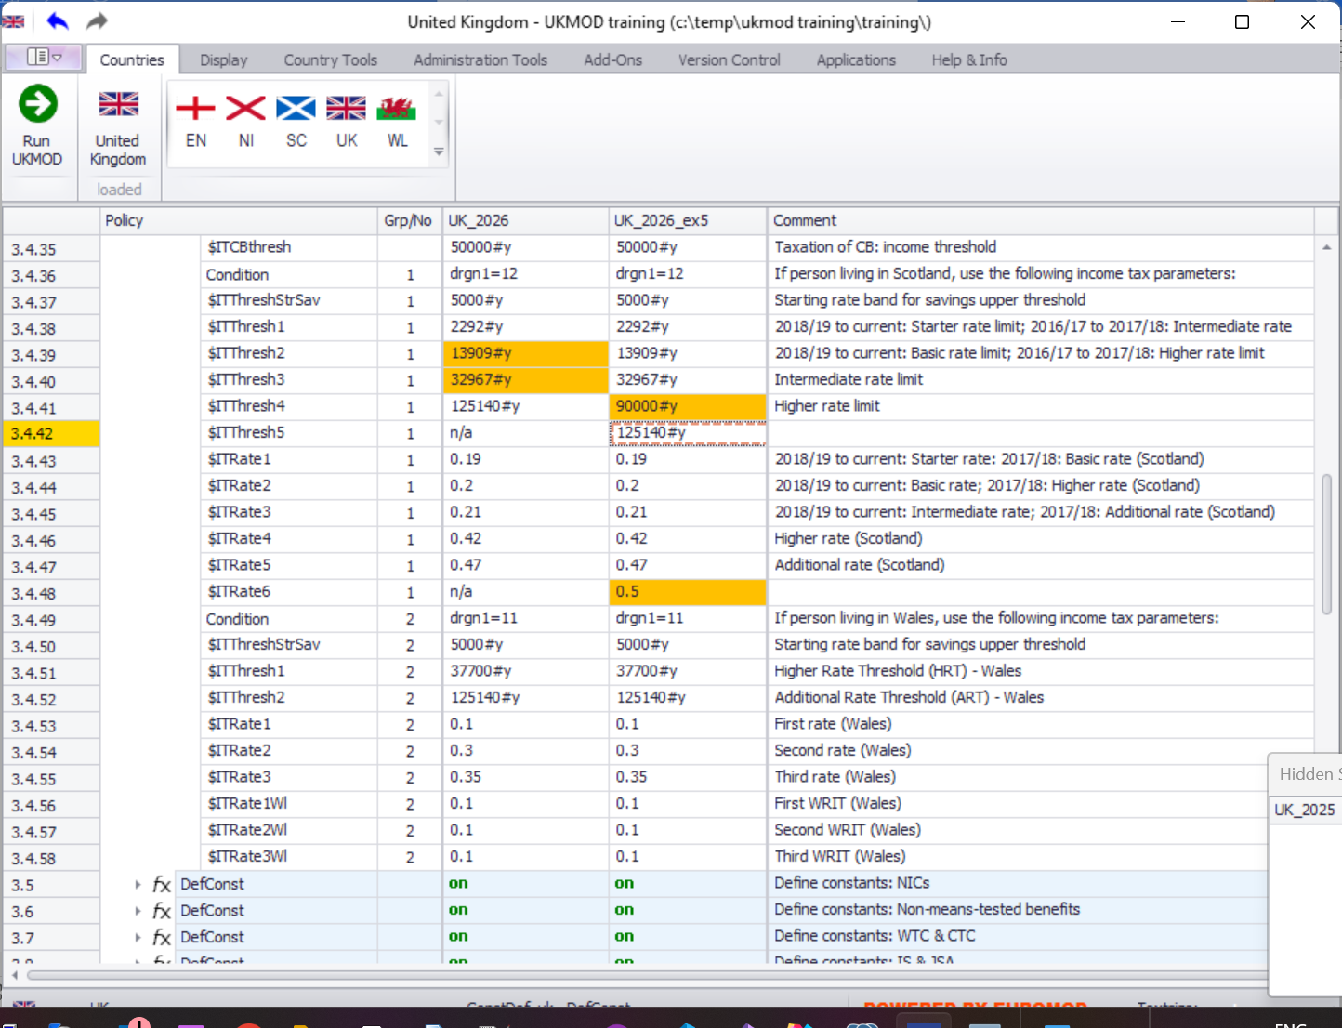

# Step 4: Run the model and analyse the output

*This step is similar to Exercise 2 – see the notes to that exercise for extended details.*

* Save the model.
* Run the model for the two systems of interest (*UK_2026* and *UK_2026_ex5*).
  + Remember to change the Dataset to *training_data*.
* Start the Statistics Presenter and select the Baseline/Reform template.
* Select output data to assume for the *baseline* and *alternative* scenarios.
* Inspect the results.

Figure 5: Inspect the results

