Exercise 4: The BenCalc function
Implementing a reform using BenCalc

Objectives
- Use the BenCalc function to add a supplement to child benefit worth up to £30 per week payable to benefit units with at least two dependent children to the 2026 tax and benefit system for the UK. The supplement should be withdrawn until it is exhausted at the rate of £1 per week for each £10 of employment earnings per week, on any employment earnings in excess of £20,000 per year.
- Analyse effects of the reform.

Directions
We will implement the new reform by extending child benefit and use the Statistics Presenter to analyse the associated effects.

- Open UKMOD and access the UK policy descriptions.
- Copy the UK_2026 system and call the copy UK_2026_ex4.
- Open the child benefit policy (bch_uk).
- Append a new BenCalc function to the bch_uk policy.
  - Use the default parameters provided for BenCalc to add a supplementary benefit worth £30 per week for all benefit units with at least two dependent children (mirroring the policy considered in Exercise 3).
  - Add Withdraw parameters to the new BenCalc function to allow for means-testing of the supplementary benefit.
- Save the model changes.
- Run both UK_2026 and UK_2026_ex4.
- Use the Statistics Presenter’s Baseline/Reform template to analyse the distributional effects.

Exercise 4: The BenCalc function
Step-by-step solutions and further information

Step 1: Add a new system
This step is the same as for Exercise 1 – see the notes to that exercise for extended details.
- Open the UK model, by clicking on the UK country flag.
- To work more easily with the UK_2026 system, limit the display by right-clicking on the system name (UK_2026), selecting move to hidden system box and then selecting all systems but selected.
- Right-click the system heading (UK_2026) and select the option copy/paste system, entering the new system name UK_2026_ex4.
- Access the search and replace tool by pressing Ctrl+F to find the policy bch_uk.

Step 2: Implement the desired reform
NOTE: You should analyse the existing description of policy bch_uk before attempting to alter it.
We will append the supplementary benefit to the existing code. We will do this in two stages. The first will involve replicating the reform we considered in Exercise 3 using the default parameter set of the BenCalc function, rather than the Elig and ArithOp functions. In the second stage we will extend the BenCalc function to allow for the means-test to which the supplementary benefit is subject.

Adding the BenCalc function
- Right-click on the BenCalc function in the bch_uk policy.
- Select the option Add Function After.
- Select the function BenCalc.

Figure 1: Adding the BenCalc function
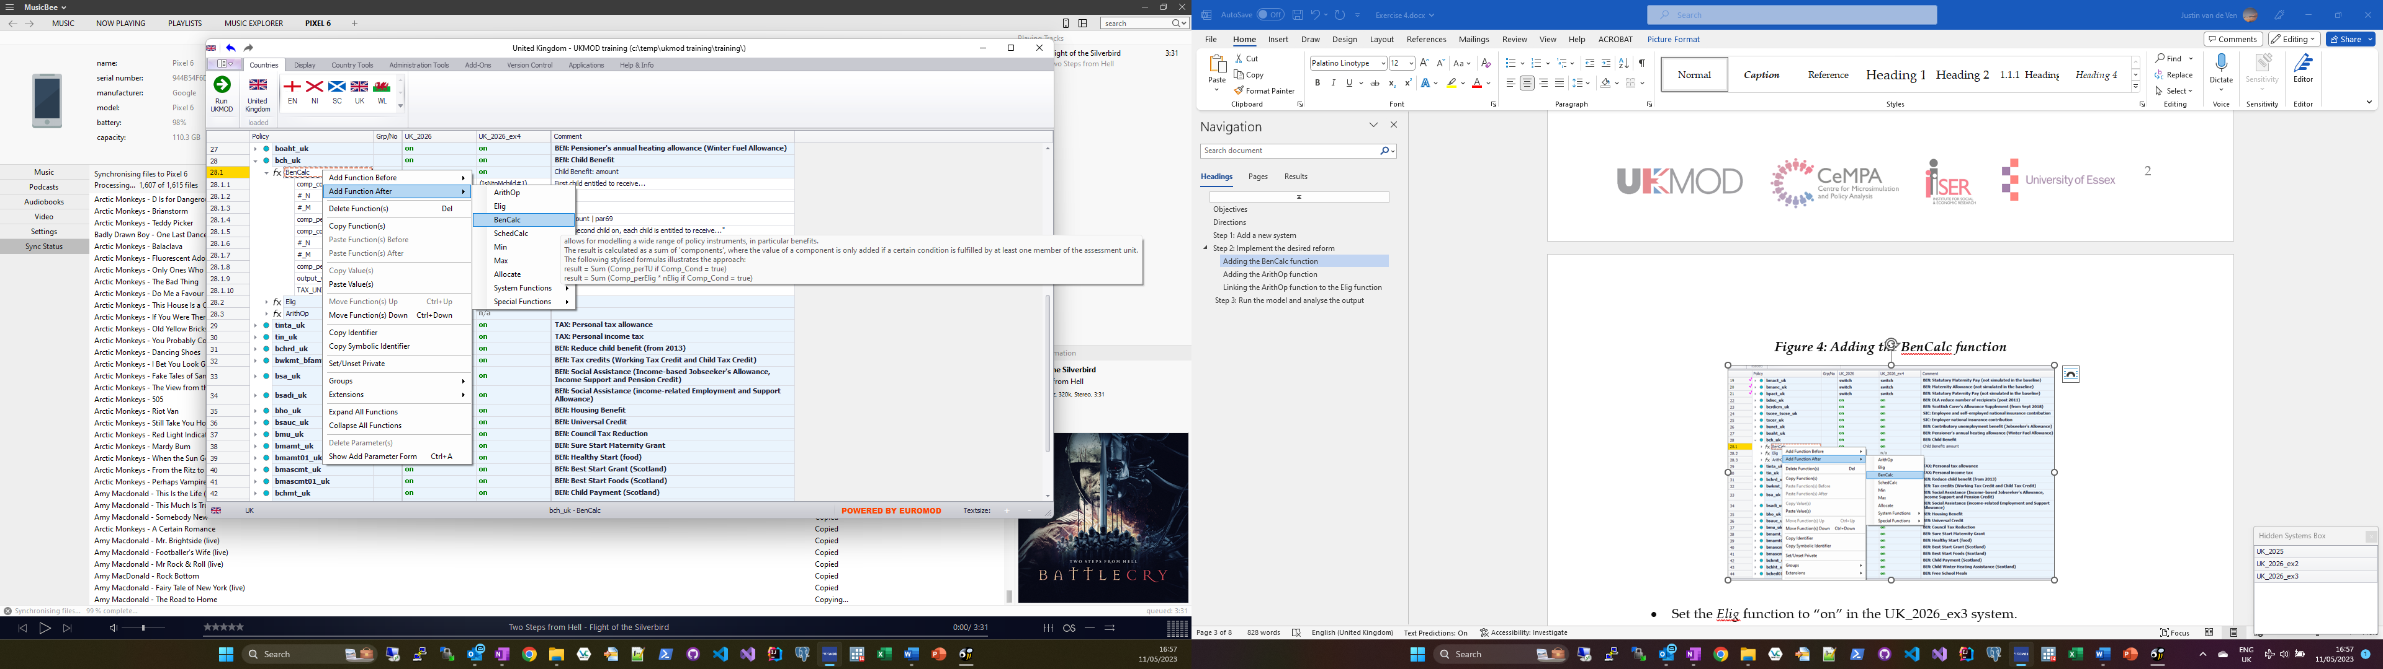

- Set the new BenCalc function to “on” in the UK_2026_ex4 system.
- Set the parameter Comp_Cond to nDepChildrenInTU > 1 in the UK_2026_ex4 system.
  - This limits evaluation to units with at least 2 dependent children.
- Set the parameter Comp_perTU to 30#w in the UK_2026_ex4 system.
- Change Output_Var of the new BenCalc function to Output_Add_Var by clicking on it and selecting “OK” in the resulting pop-up window.
- Set the Output_Add_Var of the new BenCalc function to bch_s in the UK_2026_ex4 system.
- Set the TAX_UNIT of the new BenCalc function to tu_bu_uk in the UK_2026_ex4 system.
Up to this point, we have re-created the reform considered in Exercise 3, but using the BenCalc function in place of the Elig and ArithOp functions.

Figure 2: Filling in the default parameters of the BenCalc function
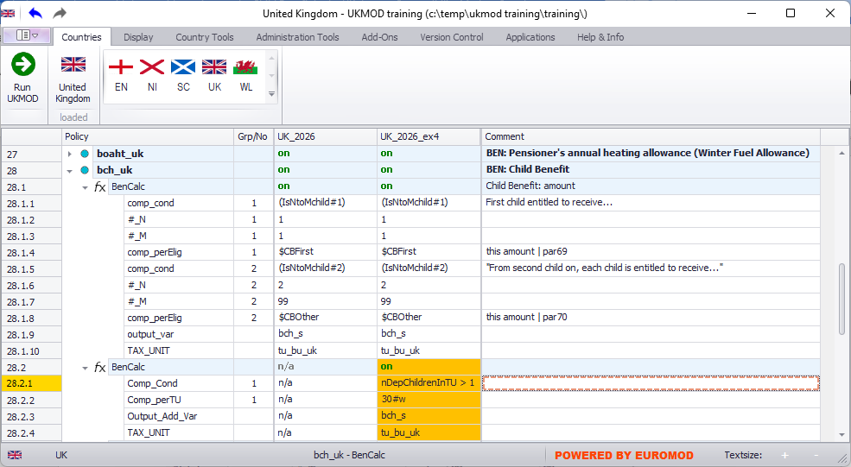

Extending the BenCalc function to reflect means-testing
- Right-click on the function or a parameter name of the new function BenCalc and select Show Add Parameter Form.
  - The Add Parameter form can also be accessed via the keyboard shortcut Ctrl+A
- In the Add Parameters form select the parameters Withdraw_Base, Withdraw_Rate, and Withdraw_Start and click the Add button.
Figure 3: Adding BenCalc parameters to control means-testing
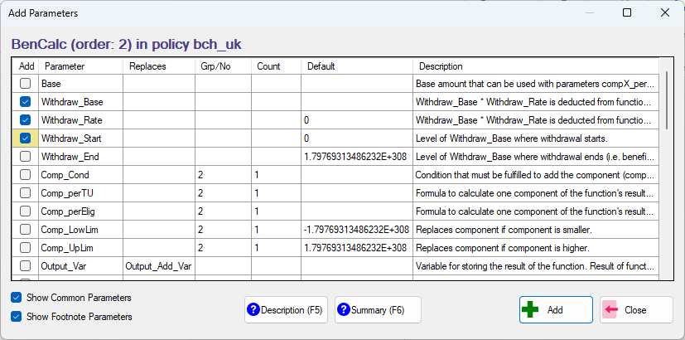
- Set Withdraw_Base parameter to yem in the UK_2026_ex4 system.
- Set Withdraw_Rate parameter to 0.1.
- Set Withdraw_Start parameter to 20000#y
  - #y denotes per year.
  - TIP: You can quickly access the help menu for any term in the policy spine by selecting the term and pressing F5.
Figure 4: The completed BenCalc function
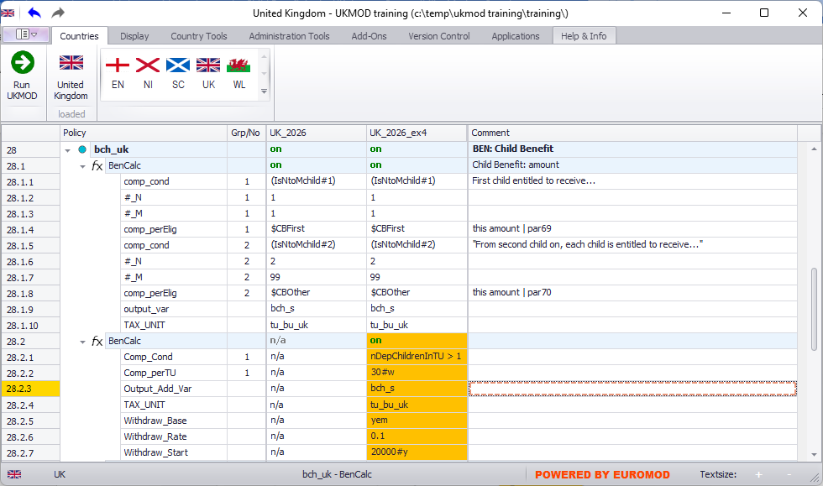

Recall that it does not matter where the above parameters appear within the BenCalc function.

Step 3: Run the model and analyse the output
This step is similar to Exercise 2 – see the notes to that exercise for extended details.
- Save the model.
- Run the model for the two systems of interest (UK_2026 and UK_2026_ex4).
  - Remember to change the Dataset to training_data.
- Start the Statistics Presenter and select the Baseline/Reform template.
- Select output data to assume for the baseline and alternative scenarios.
- Inspect the results.

Figure 5: Inspect the results
