Exercise 2: Analysing a Reform
Programming, running, and analysing a policy reform

Objectives
- Copy and paste a policy system.
- Introduce a simple policy reform to the copied policy system.
- Assess the redistributive effects of the reform.

Directions
In this exercise we will raise the value of the child benefit applicable for the first child in the UK in 2026 by £10 per week and use the Statistics Presenter to analyse the associated distributional effects.

- Open UKMOD and access the UK policy descriptions.
- Copy the UK_2026 system and call the copy UK_2026_ex2.
- Open the child benefit policy (bch_uk).
- Find the parameter name defining the benefit value for the first child.
- Check the default value for this parameter.
- In system UK_2026_ex2, replace the parameter so that the benefit increases by £10 per week.
  - Note that #w denotes weekly values in the model, so 5.00#w would indicate £5 per week.
- Save the above changes.
- Run both UK_2026 and UK_2026_ex2.
- Use the Statistics Presenter’s Baseline/Reform template to analyse the distributional effects.

Exercise 2: Analysing a Reform
Step-by-step solutions and further information

Step 1: Add a new system
- Open the UK model, by clicking on the UK country flag.
- To work more easily with the UK_2026 system, limit the display by right-clicking on the system name (UK_2026), selecting move to hidden system box and then selecting all systems but selected.
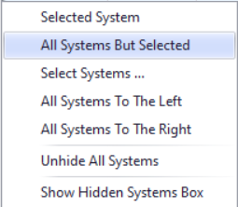
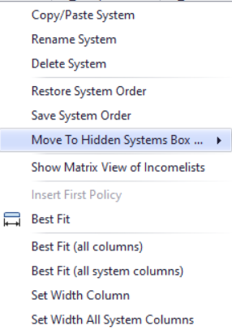
Figure 1: Focusing on a single system

- Copy the 2026 system, via either of the following alternatives:
  - Right-click the system heading (UK_2026) and select the option copy/paste system, entering the new system name UK_2026_ex2.
  - Select the Country Tools tab, and press on the Add System button, selecting UK_2026 from the list of options, and entering the new system name UK_2026_ex2.

Step 2: Analyse the bch_uk policy
- Use the Search and Replace tool to find the policy bch_uk
  - Access the tool by pressing Ctrl+F or via the Country Tools tab, Search + Replace button.
- Right-click on tin_uk and select Expand All Functions.

Figure 2: The search and replace tool
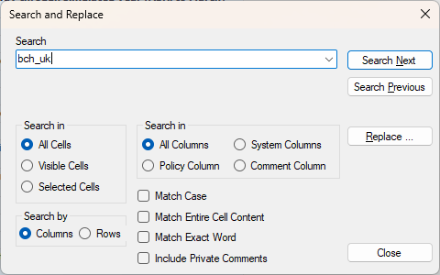
Figure 3: The (expanded) bch_uk policy
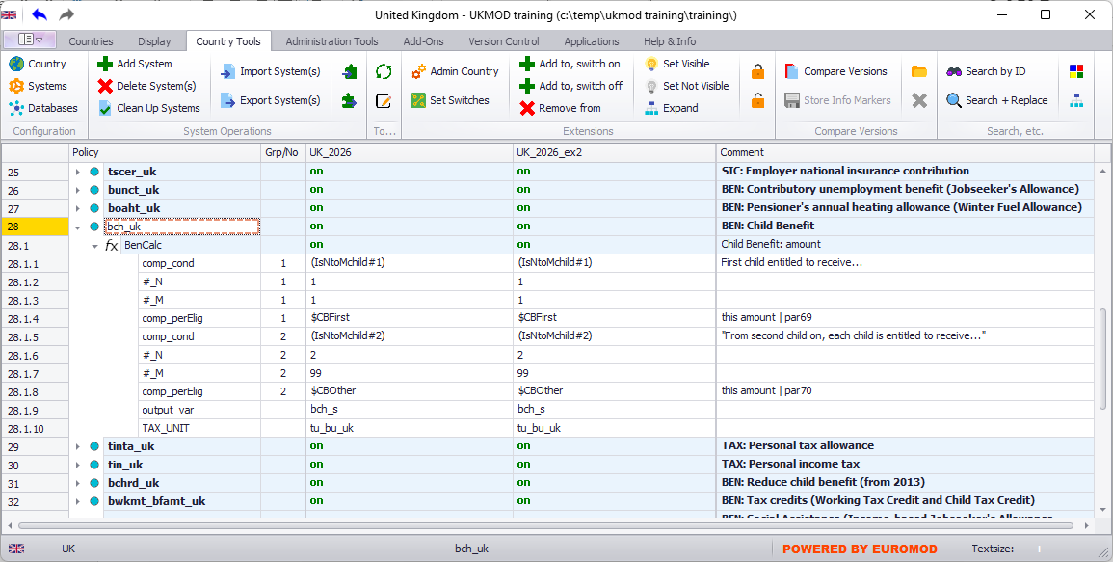

- Consider the following questions:
  - At what level – individual / benefit unit / household – is the benefit evaluated?
  - What parameters store benefit values?
    - NOTE: parameter names in UKMOD start with a $
  - What is the benefit payable for the first child?
    - Hover over the parameter, or search for it in the spine.
    - NOTE: #w in EUROMOD denotes “per week”.
  - What variable name is the benefit stored under?

Step 3: Implement the desired reform
We need to increase the value of the benefit payable for the first child from £25.45 to £35.45 per week. We can do this either by changing the value of parameter $CBFirst in the policy spine, or hard-coding the value in the bch_uk policy. It is quickest here to do the former, but you might want to try implementing the latter.
Figure 4: Hard-coding a change in parameter value
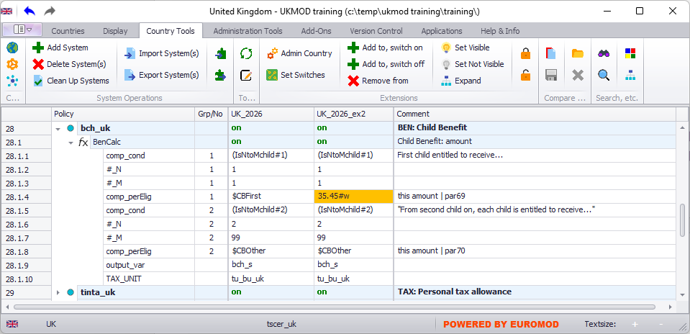
Figure 5: Saving changes to the model
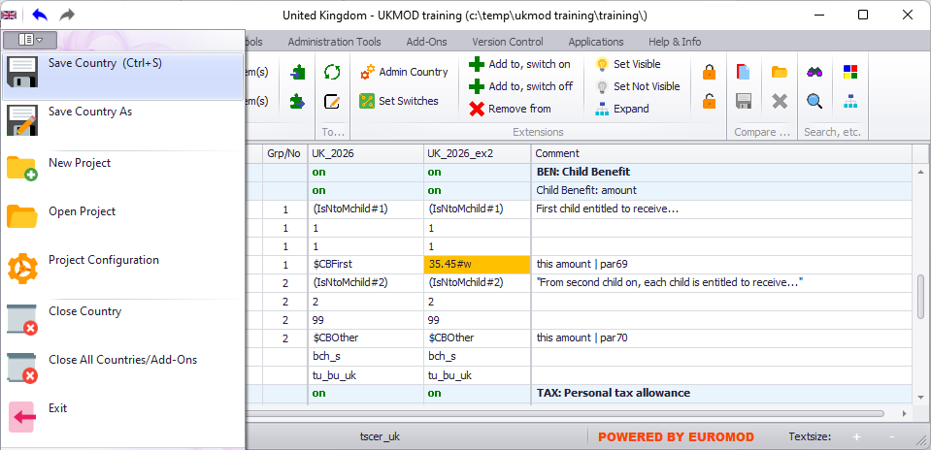

Step 4: Run the model and analyse the output
In this step we run the model for the new policy set-up as described above and use the Statistics Presenter to generate summary statistics describing the distributional impact that the considered reform has on simulated output. These tasks are similar to those performed in Exercise 1.
Figure 6: Running the model
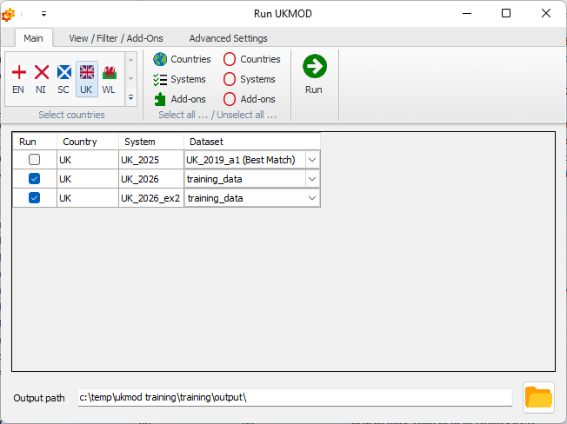
Figure 7: Using the Baseline/Reform template of Statistics Presenter
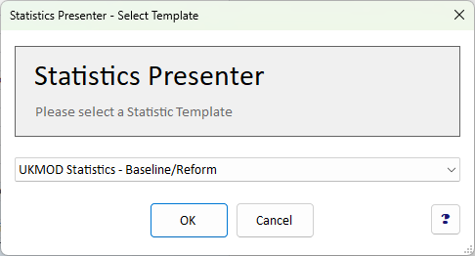

Figure 8: Selecting model output for analysis
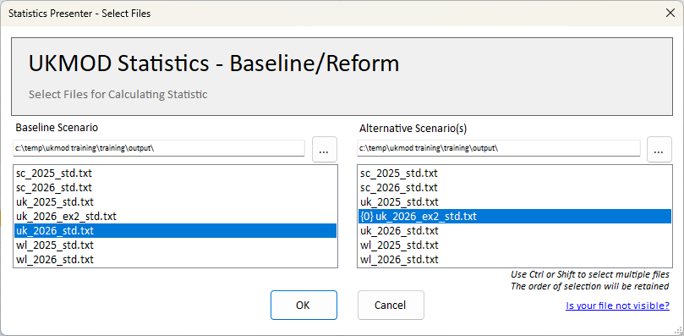
Figure 9: Inspecting results
