Exercise 1: Getting Started

Running UKMOD and analysing output

# Objectives

* Run UKMOD and produce output files.
* Use the Statistics Presenter to generate summary statistics.
* Compare distributional statistics across policy years.
* Assess the redistributive effect of taxes and benefits.

# Directions

The Statistics Presenter provided with UKMOD can be used to calculate a range of common summary statistics for simulated output. Amongst others, it computes population aggregate measures of income, taxes, and benefits; poverty and inequality indices for the overall population and for selected subgroups; and measures that describe the importance of alternative income sources, distinguished by population subgroup. Calculations are based on UKMOD standard micro-data output, which includes variables for disposable income and its components (original income, benefits, taxes and social insurance contributions).

* Open UKMOD and access the UK policy descriptions.
* Run UKMOD for 2025 and 2026.
* Use the Statistics Presenter to analyse the effects on inequality and poverty of moving from the transfer system from 2025 to 2026.

Exercise 1: Running UKMOD

Step-by-step solutions and further information

# Step 1: Producing micro-data output

Run UKMOD to produce micro-data output for the UK. The model can be run for one country at a time, or the user can select several countries (and systems) to run at once.

* In the Countries tab on the ribbon bar press the *Run UKMOD* button. This will bring up a dialogue box.
* In the dialogue box, select the UK by pressing on the UK flag (if not already selected). This will display the available systems in the UK.
* Select *UK_2025* and *UK_2026* by clicking the corresponding boxes.
  + Alternatively, use the *Select all… Systems* button in the top panel.
* For these two systems, select *training_data* as the target dataset.
* Check (and if necessary, modify) the output path where you would like UKMOD to write simulation output (bottom of window).
* Click on the Run button in the dialogue box.

Figure 1: Producing micro-data output for the UK

Figure 2: Running UKMOD

Figure 3: Completed simulation

After completing the above, UKMOD will have saved output for the UK for 2025 and 2026 system years – further information can be obtained via the EUROMOD *Help & Info* tab, select the *Help* button, and type *Running EUROMOD* under the *Search* tab. The Run and Error logs for a simulation can be viewed by clicking on these buttons when they are active in the windows displayed in Figures 2 and 3. It is often useful to note any errors/warnings reported by UKMOD, a subject that we return to in a subsequent exercise.

# Step 2: Using the Statistics Presenter

## Using the default Statistics Presenter template

* To access the Statistics Presenter, click on the Applications tab of the main EUROMOD window, and click on the *EUROMOD Statistics* button and select “Statistics Presenter”

Figure 4: Accessing the Statistics Presenter

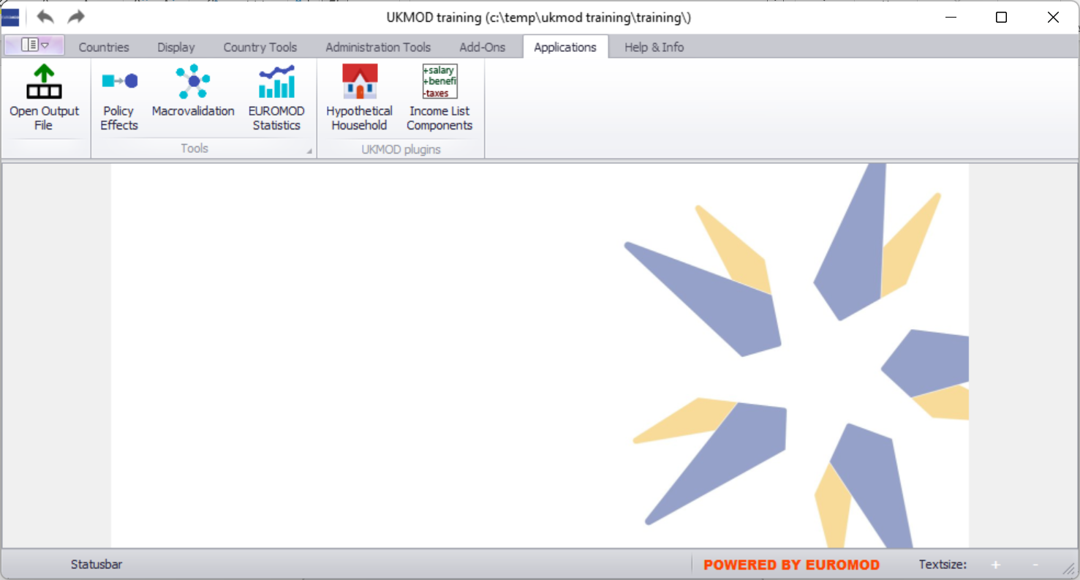

Figure 5: Selecting the default Statistics Presenter template

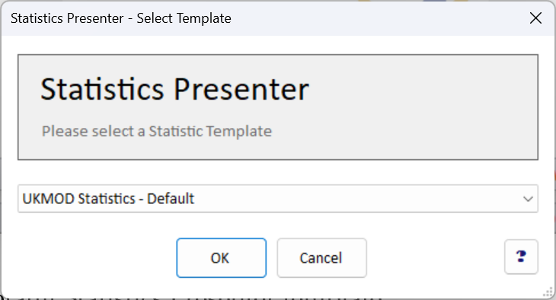

Figure 6: Selecting output files to analyse

Figure 7: Output from the default Statistics Presenter template

* You can find the summary statistics in the sheet *UK_2025* and *UK_2026* respectively (bottom left).
* The results can be saved in Excel table by clicking on the export button (top right).
* Compare the poverty and inequality indices between the two systems (statistics tabs).

## Using the Multi-system Statistics Presenter template

Figure 8: Selecting the MultiSystem Statistics Presenter template

Figure 9: Output from the MultiSystem Statistics Presenter template

* Template produces side-by-side statistics for multiple systems.