Exercise: BVR add-on
Analyse behavioural responses to a change in income tax rates

Objectives
- Use the BVR add-on to simulate behavioural responses to a 5-percentage point increase in the basic rate of tax for people residing in England and Northern Ireland in 2026.
- Analyse effects of the reform.

Directions
- Open UKMOD and access the UK policy descriptions
- Run a base-line simulation of the UK_2026 system using the training_data.txt input data
- Use the BVR add-on to generate working statistics for the base-line simulation (UK_2026 system and training_data.txt) – may take some time
- Copy working statistics from the output file uk_2026_bvr.txt to training_data.txt
  - Output variables mntr_earns_s, mntr_ypp_s, mntr_yprtx_s, mntr_yiytx_s, mntr_other_s, ntax_s, renaming each to omit the appended “_s”
- Copy the UK_2026 system and name the copy UK_2026_ex1
- Implement a 5-percentage point increase in the basic rate of tax by adjusting parameter $ITRate1 in system UK_2026_ex1
- Save the model changes
- Run the BVR add-on for the UK_2026_ex1 system and training_data
- Use the Statistics Presenter’s Behavioural responses template to analyse effects of the reform

Exercise: BVR add-on
Step-by-step solutions and further information

Step 1: Projections for default system
- Open the UK model, by clicking on the UK country flag.
- Select the “Run” button
- From the “Run UKMOD” window, select the checkbox under the “Run” column on the “UK_2026 System” row, and select “training_data”
- Press the “Run” button
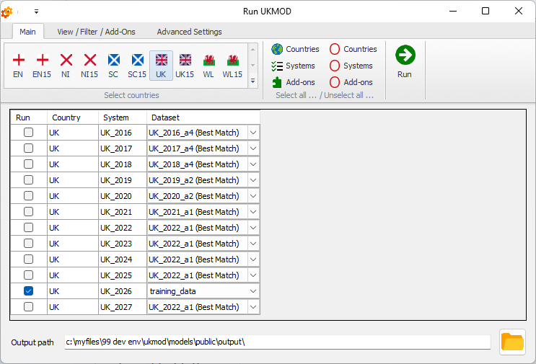

Step 2: Evaluate working statistics for reference simulation
- Open the “Run UKMOD” window via the “Run” button
- Select the “View / Filter / Add-Ons” tab
- Turn on the “Auto Rename” feature
- Choose the BVR option from the add-ons drop-down menu
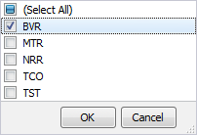
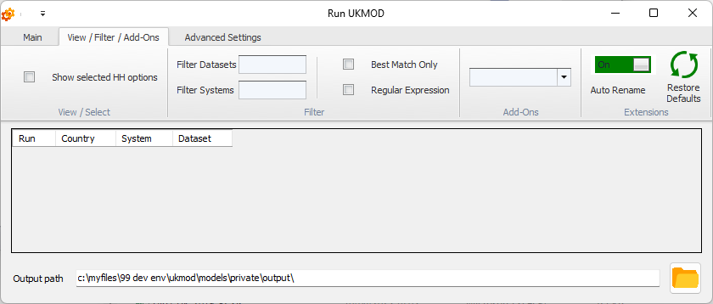

- Select the “Main” tab
- Select the checkbox under the “BVR” column on the “UK_2026 System” row, and “training_data”
- Press the “Run” button

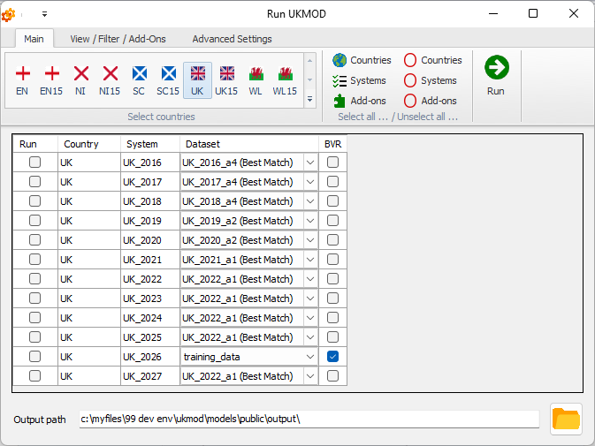

Note: Some “warning” messages may appear, which can be ignored
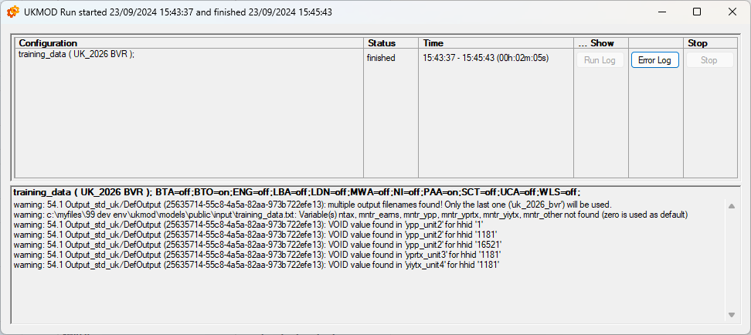

Step 3: Add reference statistics to the input data
- Use Excel to open the output file “uk_2026_bvr.txt” and the input file “training_data.txt”
- Add “mntr_earns” data to the input file:
  - In the output file (uk_2026_bvr.txt), search for “mntr_earns_s”
  - Copy this column of data and append the data to the right-most column of the input data (training_data.txt).
  - Edit the name at the top of the column to “mntr_earns”.
- Repeat the above process for “mntr_ypp_s”, “mntr_yprtx_s”, “mntr_yiytx_s”, “mntr_other_s” and “ntax_s”
- Save and close the input data file
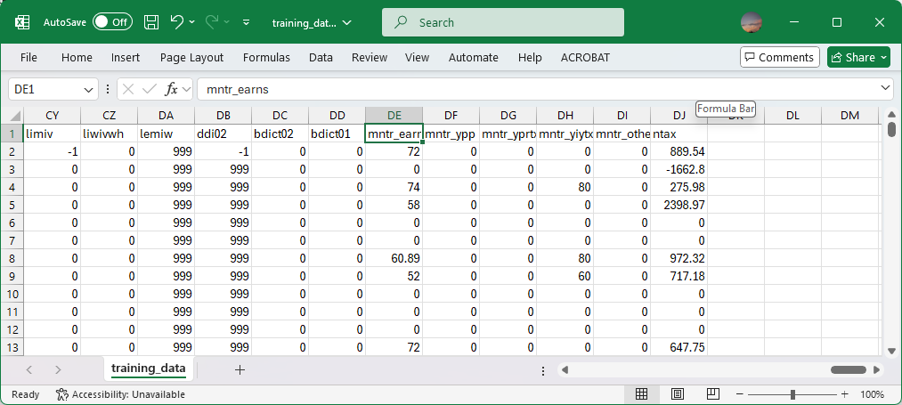

The mode is now set-up to analyse behavioural reforms to the 2026 system. Note that the input data would need to be updated as described above to consider reforms relative to any other system and/or input data set.

Step 4: Specify policy reform
- Open the UK model
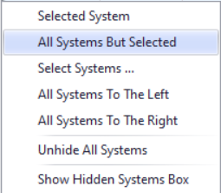
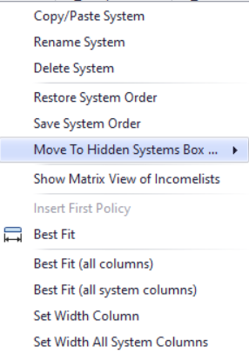
- To work more easily with the UK_2026 system, limit the display by right-clicking on the system name (UK_2026), selecting move to hidden system box and then selecting all systems but selected

- Copy the 2026 system, via either of the following alternatives:
  - Right-click the system heading (UK_2026) and select the option copy/paste system, entering the new system name UK_2026_ex1
  - Select the Country Tools tab, and press on the Add System button, selecting UK_2026 from the list of options, and entering the new system name UK_2026_ex1
- Navigate to the income tax parameters of the UK_2026_ex1 system and increase the value of parameter $ITRate1 from 0.2 to 0.25 (as shown below)
- Save the model (CNTRL + s)
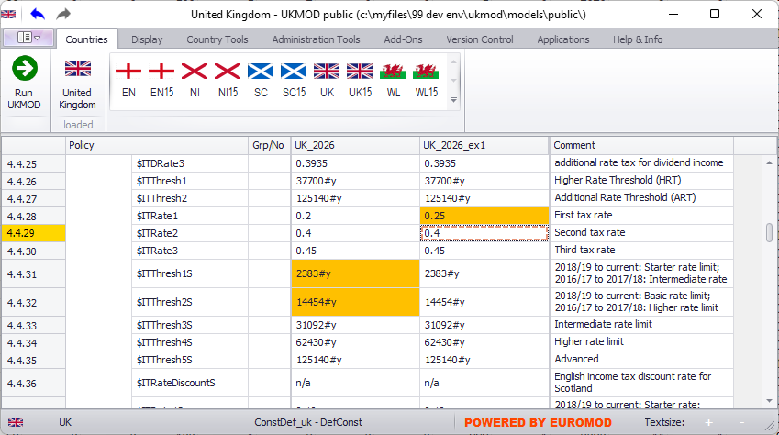

Step 4: Run the model and analyse the output
- Re-run the BVR add-on for the new system “UK_2026_ex1” on the expanded data “training_data.txt”

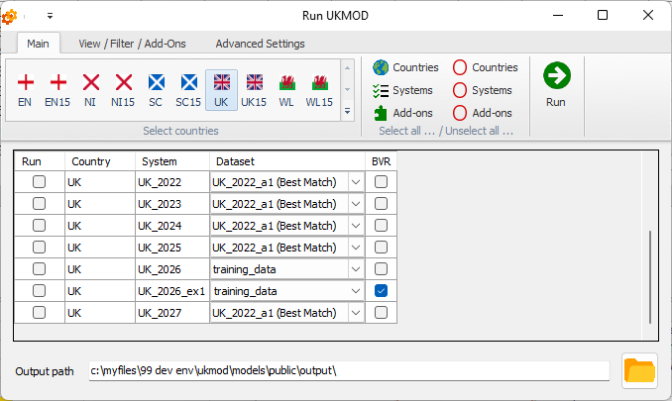

- When the simulation is complete, open the “Statistics Presenter” selection window, and select “UKMOD Statistics – Behavioural responses” from the drop-down menu

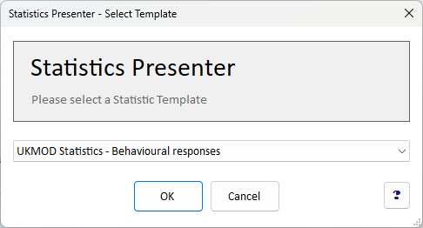

- Under the Baseline Scenario, select the “uk_2026_std.txt” output, under the Alternative Scenario select the “uk_2026_ex1_bvr.txt” output, and press “OK”

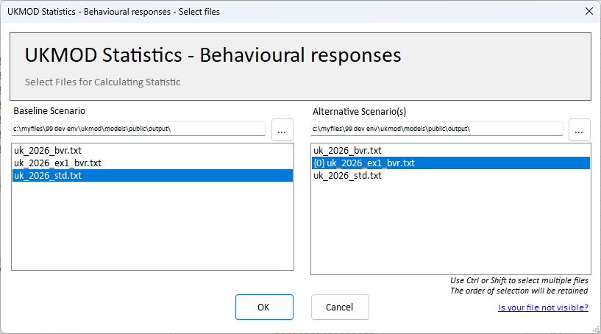

When the statistics presenter window is populated you can inspect associated results (NOTE: results below are for test data only)
