Exercise 3: Change tax rates in BI loop

Uses:
- Learn how to use the loop function in UKMOD
- Perform a policy reform in the tax schedule and find the new amount of BI to achieve revenue neutrality using a loop
- Check new BI amount in output file
- Run reformed system and analyse its distributional impact using the Statistics Presenter

Description:
In this exercise you are going to fix new tax rates and investigate what level of Basic Income is now possible while maintaining fiscal balance.

You are going to use the BI_BIloop system, which already has the loop policy coded.

The task is to change the increments to the income tax rates of UK and Scottish tax payers. We want to make the tax schedule more progressive, so we are increasing tax rates by:
- Basic tax rate (starter, basic and intermediate rates for Scotland): +3 ppts (baseline increment defined by i_t)
- Additional tax rate (higher rate in Scotland): +6 ppts (2*i_t)
- Higher tax rate (top rate in Scotland): +9 ppts (3*i_t)

In more detail, you will make a copy of the BI system and call it UK_BI_BIloopref3. Then you will modify the reform system:
- Go to where the income tax schedule is defined in UKMOD (tin_uk, line 33 – change for UK and for Scotland)
- Change the tax rates to reflect the changes above
- Change the starting BI amount
- Save your changes

When you are done with your changes to the reform system, run the model for the baseline system UK_BI_BIloop and reform system UK_BI_BIloopref3. Open the BI_BIloopref3 output file in UKMOD and check the new BI amount (search for buc_s). Use the Statistics Presenter – Baseline/Reform option – to check convergence and analyse the distributional effect of the reform.

Exercise 3: Change tax rates in BI loop

Step-by-step solution and further information:

In more detail, you will make a copy of the BI system and call it UK_BI_BIloopref3. Then you will modify the reform system:
- Go to where the income tax scheduled is defined in UKMOD (tin_uk, line 33)
- Change the tax rates to reflect the changes above
- Save your changes

Step 1: Creating reform system for UK_BI_BIloop
Open the UK model, by clicking on the UK country flag. To work more easily with the UK_BI_BIloop system, hide all other systems, by right-clicking on the system name (UK_BI_BIloop), selecting “Move To Hidden Systems Box” and then selecting “All Systems But Selected”.

Figure 1: Hiding a system
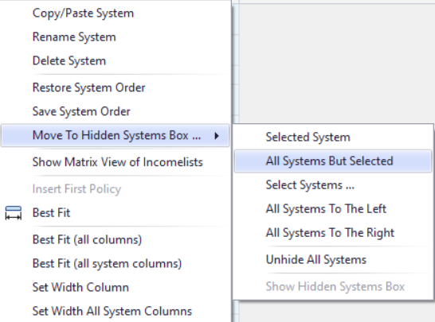

Add new system from UK_BI_BIloop. Right-click on the system heading UK_BI_BIloop and select the option ‘copy/paste system’. Specify a name for the reform system (type e.g. UK_BI_BIloopref3).

Figure 2: Adding a reform system using the copy/paste option

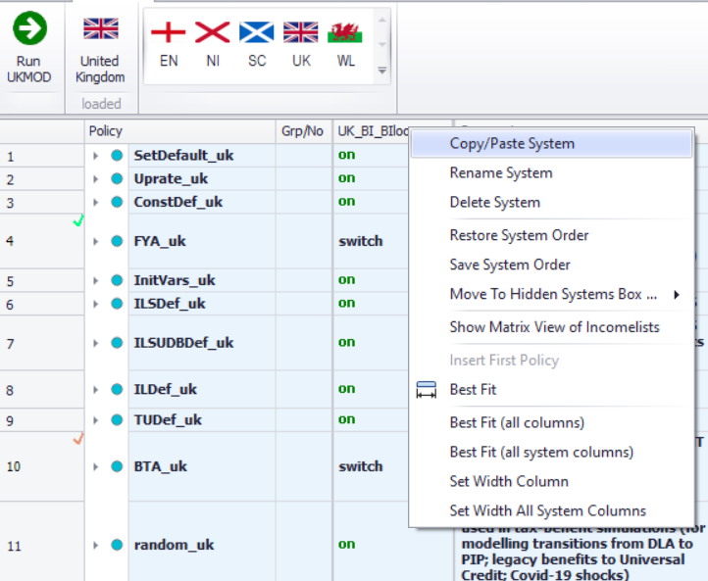

Figure 3: Giving a name to the reform system

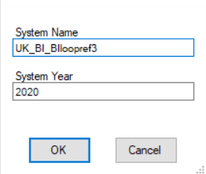

Step 2: Implementing the reform

The task is to change the increments to the income tax rates of UK tax payers (excluding Scotland). We are increasing tax rates by:
- Basic tax rate: +3 ppts (baseline increment defined by i_t)
- Additional tax rate: +6 ppts (2*i_t)
- Higher tax rate: +9 ppts (3*i_t)

Go to where the income tax schedule is implemented in UKMOD (tin_uk, line 33).

Figure 4: Tax schedule in UKMOD (tin_uk)

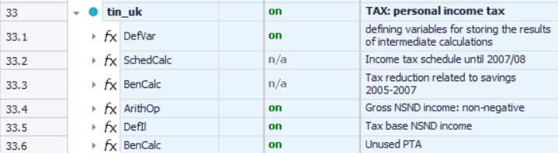

In there, search for the personal income tax schedule that currently applies (Income tax schedule since 2008/09 with possible additions) and change the tax rates as instructed above.

Figure 5: New tax rates for UK income tax schedule (excluding Scotland)

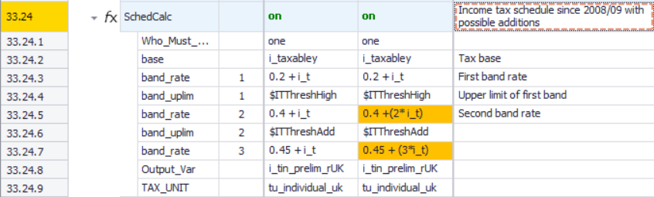

Now do the same for the Scottish income tax schedule (line 33.27).

Figure 6: New tax rates for Scottish income tax schedule

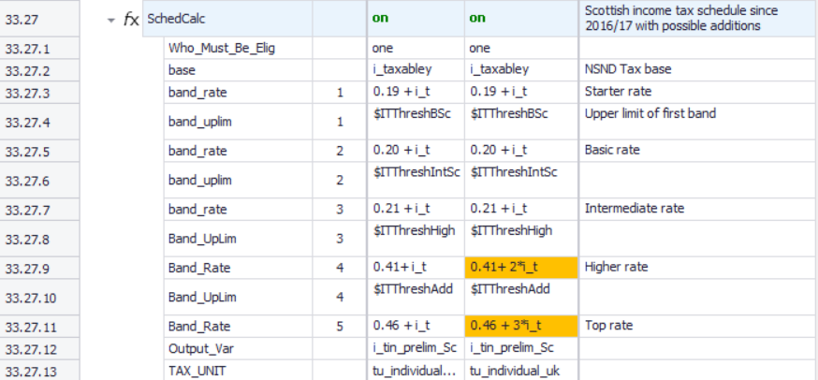

In order to speed up the loop convergence, we recommend that you change the initial BI amount on which the loop will start its calculations. You do this by going to where the Basic Income variables are defined, in 1.18.

We’re increasing the revenue by increasing the income tax rates so we should get the starting amount starting at a higher amount (e.g. £5,600).

Figure 7: Changing BI starting value for BI loop

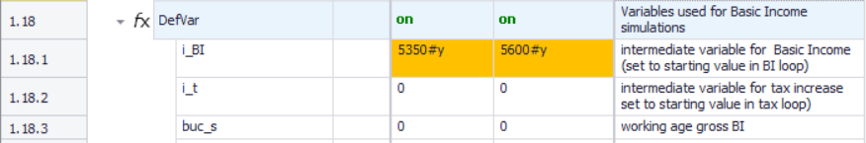

Save your changes.

Step 3: Produce and analyse the micro-data output
Run the model to produce micro-data output for the baseline and reform systems.

Figure 8: Running the baseline and reform systems

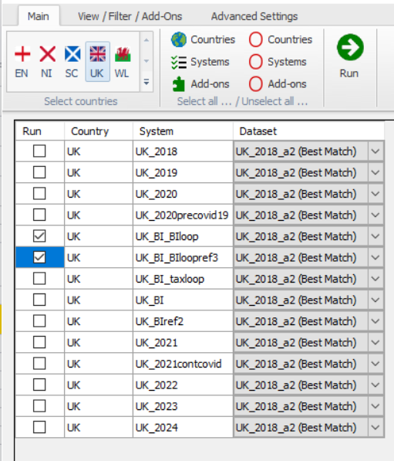

Open the output files through UKMOD to check BI levels in both systems, by searching for variable buc_s.

Figure 9: Open Output File in UKMOD
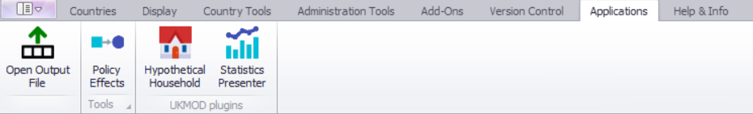

Figure 10: Excel output file BI_BIloopref3

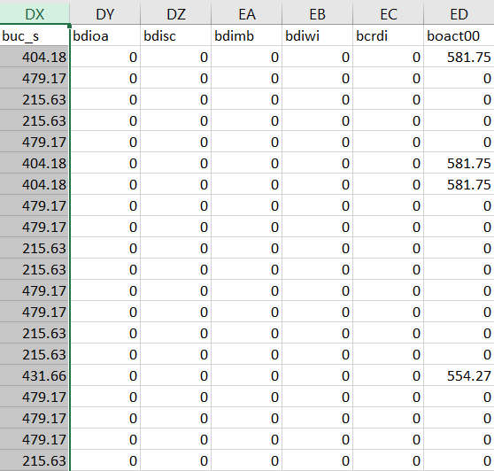

The new (gross) BI level for working-age adults is £479.17 per month - or £5,750.04 per year. This is compared to £5,450.04 in the baseline system (£454.17 /month)

Now use the Statistics Presenter – option Baseline/Reform – to analyse differences in government revenues due to the changes in tax base.

Figure 9: Opening Statistics Presenter – Baseline/Reform option

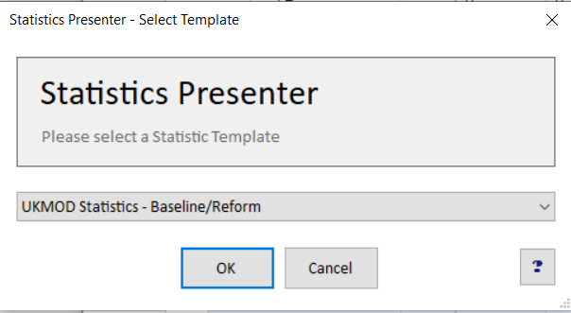

Solution
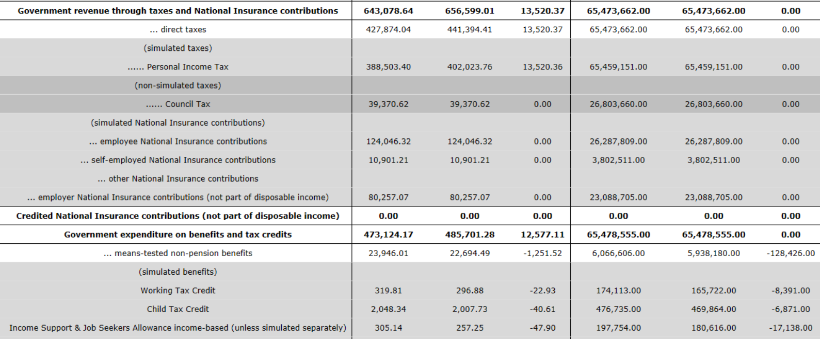

To note: Lower spending and fewer people on means-tested benefits because BI slightly more generous.
To note: The difference to base for revenue and expenditure is close (<£1bn, which means we achieved convergence.

