Exercise 2: Alternative way to children’s BI (using Child Benefit)

Uses:
- Understand how Basic Income can be allocated to a particular group (e.g. pensioners and children) in a different way.
- Perform a policy reform that involves using Child Benefit as the UBI for children.

Description:
In our baseline Basic Income scenario children receive their own BI that is a proportion (45%) of the working-age adult’s BI. Children’s and adults’ BI interact with the tax-benefit system in the same way.

But another way of giving a BI to children is to adapt the current Child Benefit policy, which in the UK is very close to a universal entitlement to children (except for very high-income families). This means, as opposed to the baseline policy’s child’s BI which is taxable and enters the means-test for means-tested benefits, a BI paid as Child Benefit would be neither taxable nor means tested.

In this exercise you will change the way a BI is given to children to use the current Child Benefit policy.

In more detail, you will make a copy of the BI system and call it UK_BIref2. Then you will modify the reform system:
- Go to the BI policy (line 29) and create two ArithOp functions to replace CB constants (for first-borns and following children) with a proportion of adult (net) BI
- Check that the Higher Income Child Benefit Charge (line 34) does not apply (on the same grounds)
- Check that Child Benefit is not included in the benefit cap (line 8.24) (since it should not apply to basic income)
- Save your changes.

When you are done with your changes to the reform system, run the model for the baseline system UK_BI and reform system UK_BIref2. Use the Statistics Presenter – Baseline/Reform option – to analyse the distributional effect of the reform.

Exercise 2: Alternative way to children’s BI (using Child Benefit)

Step-by-step solution and further information:

In more detail, you will make a copy of the BI system and call it UK_BIref2. Then you will modify the reform system:
- Go to the BI policy (line 29) and create two ArithOp functions to replace CB constants (for first-borns and following children) with a proportion of adult (net) BI
- Check that the Higher Income Child Benefit Charge (line 34) does not apply (on the same grounds)
- Check that Child Benefit is not included in the benefit cap (line 8.24) (since it should not apply to a universal basic income)
- Save your changes.

Step 1: Creating reform system for UK_BI
Open the UK model, by clicking on the UK country flag. To work more easily with the UK_BI systems, hide all other systems, by right-clicking on the system name (UK_BI), selecting “Move To Hidden Systems Box” and then selecting “All Systems But Selected”.

Figure 1: Hiding a system
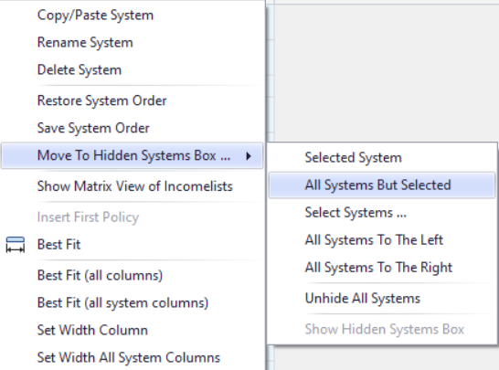

Add new system from UK_BI. Right-click on the system heading UK_BI and select the option ‘copy/paste system’. Specify a name for the reform system (type e.g. UK_BIref2).

Figure 2: Adding a reform system using the copy/paste option

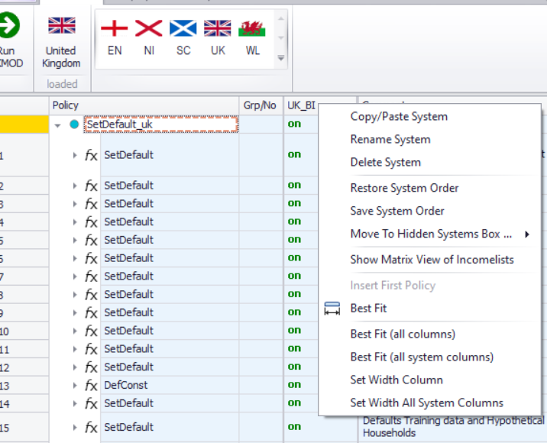

Figure 3: Giving a name to the reform system

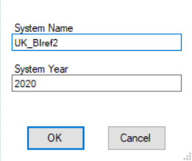

Step 2: Implementing the reform

We want to replace the Child Benefit constants with the proportion of adult BI we set. You can do this directly in the Basic Income policy. First you need to go to the function that assigns a BI to adults and children and assign 0 to children.

Figure 4: Assigning adult’s and child’s BI – children get 0

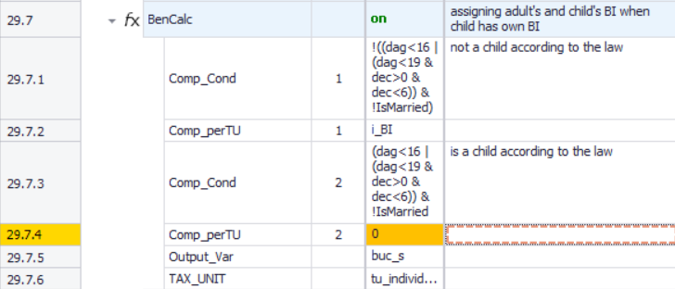

In buc_uk you need to create two ArithOp functions. These functions will replace the Child Benefit values defined in constants in line 3.6.1-2.

Figure 6: Child Benefit constants

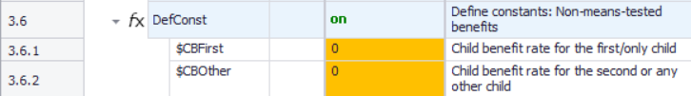

Make a note of these two constants to use in the new ArithOp formulas.

Create the ArithOp functions underneath the one you switched off in buc_uk. To do this, right-click on the cell above and select ‘Add Function After - ArithOp’.

Figure 7: Creating a new ArithOp function

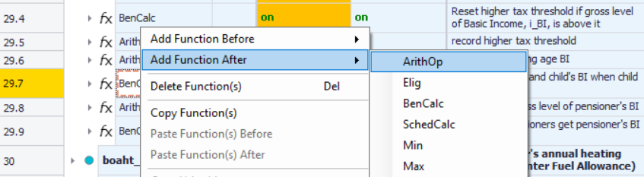

In the formula cell, you should put a proportion of adult (net) BI, using the variables that define each ($Cprop and *netBI_s). You want this to become the CB constant, so your Output_Var is the CB constant $CBFirst. Your tax unit is the individual.
Figure 8: New ArithOp function to use CB as children’s BI (first-borns)

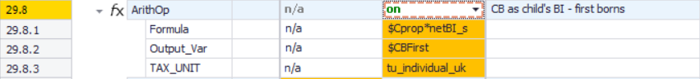

Repeat this process for the following children.

Figure 9: New ArithOp function to use CB as children’s BI (other children)

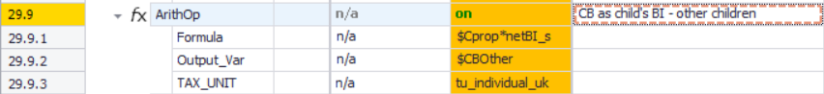

Don’t forget to turn on both functions!

This will effectively determine the new CB constants that are set to zero in lines 3.6.1-2.

Next you can check whether the policy to not award Child Benefit to high-income families is switched off. You can find this in line 34 (switched to n/a on baseline BI scenario as well).

Figure 10: Policy to reduce child benefit

You can also check that the Child Benefit is not included in the benefit cap (in line 8.24).

Figure 9: Income list for benefit cap (il_bencap)

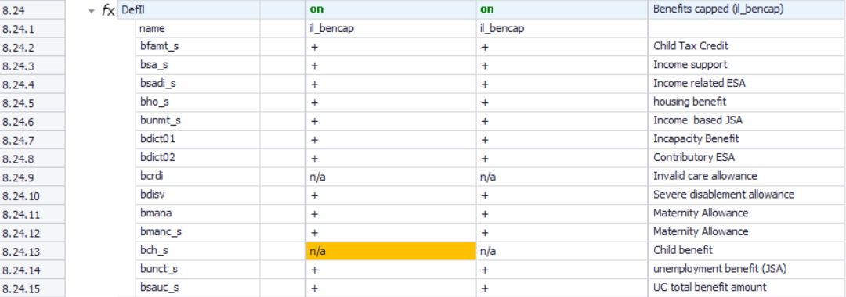

Remember: only make changes in the reform system!

Save your changes.

Step 3: Produce and analyse the micro-data output
Run the model to produce micro-data output for the baseline and reform system. Use the Statistics Presenter – option Baseline/Reform – to analyse differences in government revenues due to the changes in tax base.

Figure 10: Producing micro-data output for the baseline and reform systems
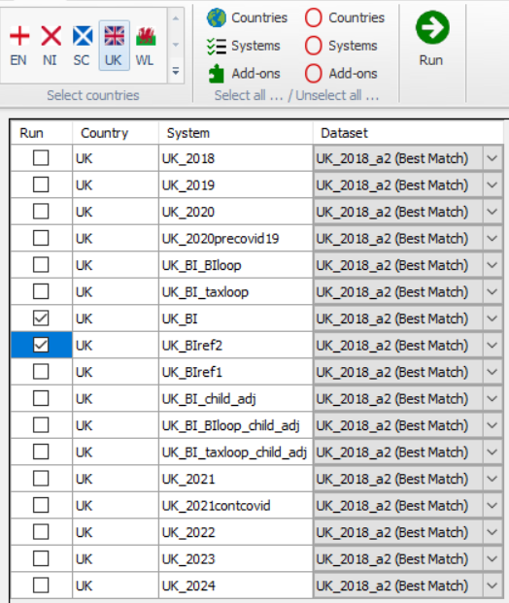

Note: If you have completed Exercise 1 and ran UK_BI, no need to choose it this time!

Figure 11: Opening Statistics Presenter – Baseline/Reform option

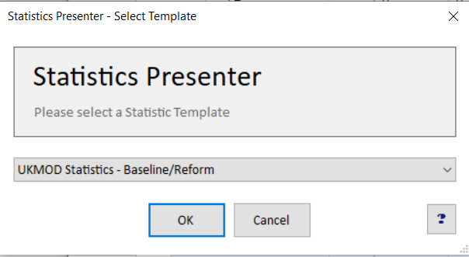

Figure 12: Selecting the relevant output files with the Statistics Presenter

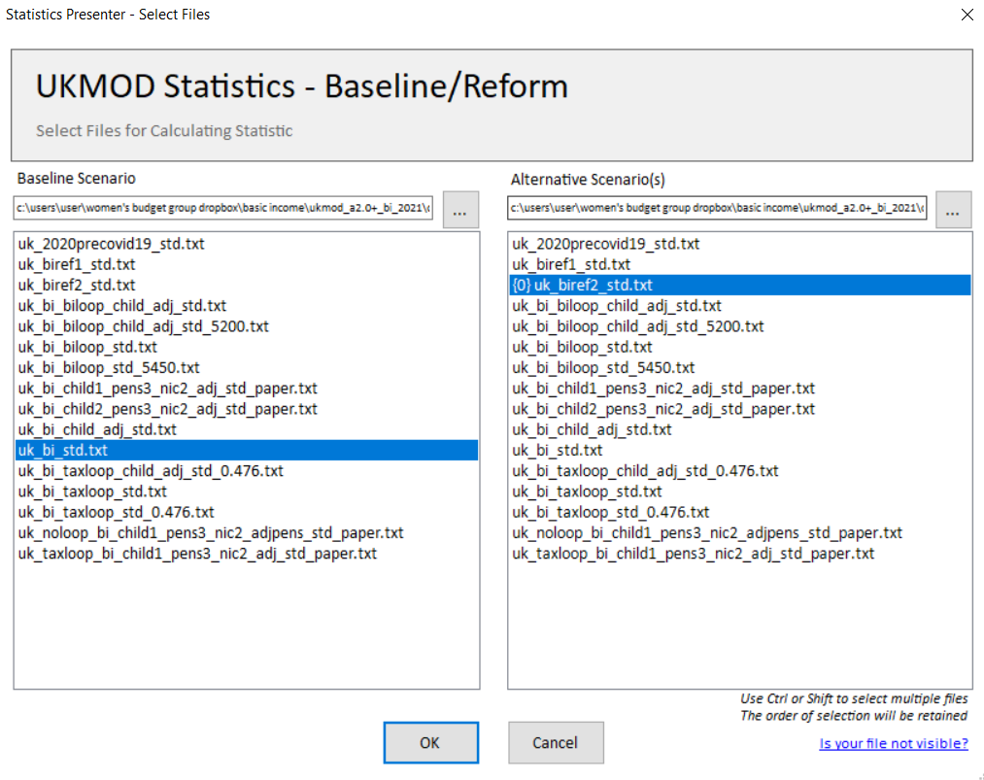

Solution
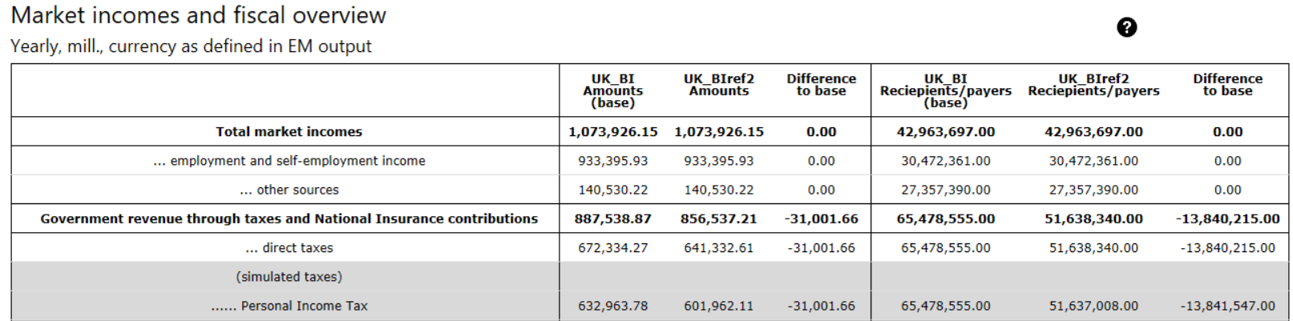
To note: fewer tax payers (children no longer paying tax because Child Benefit not taxable) and therefore less revenue from personal income tax.

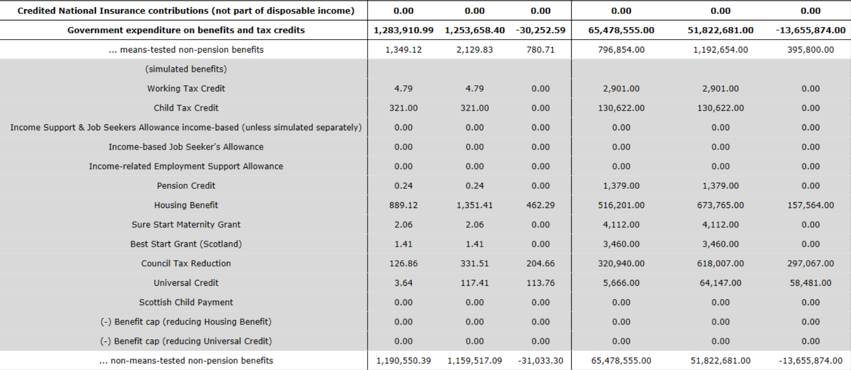

To note: higher spending on means-tested benefits because benefit cap will apply to fewer households. But lower gross spending on non-means-tested benefits overall (the extra spending on Child Benefit in the reform system is less than the gross spending on Basic Income for children in the baseline system).

Note: Basic Income doesn’t appear directly in the Statistics Presenter ‘Market Incomes and Fiscal Overview’ table.

