Exercise 1: Making Basic Income non-taxable

Uses:
- Understand how a Basic Income policy interacts with the tax and benefit systems.
- Perform a policy reform that involves changing one element of that interaction: making BI non-taxable (from a taxable baseline).

Description:
In our baseline Basic Income scenario the amount of BI that people receive is taxed.

For UKMOD coding purposes, this means that the BI policy is added to the tax relevant income lists and variables are needed in the BI policy for both gross and net BI amounts.

In this exercise you will change this to make sure Basic Income is not taxed.

In more detail, you will make a copy of the BI system and call it UK_BIref1. Then you will modify the reform system:
- Go to Non-Standard Income lists and remove the BI policy from the ones relevant to tax.
- Go to the BI policy in the policy spine and check the gross and net variables are the same (in each age category).
- Save your changes.

When you are done with your changes to the reform system, run the model for the baseline system UK_BI and reform system UK_BIref1. Use the Statistics Presenter – Baseline/Reform option – to analyse the distributional effect of the reform.

Exercise 1: Making Basic Income non-taxable

Step-by-step solution and further information:

In more detail, you will make a copy of the BI system and call it UK_BIref1. Then you will modify the reform system:
- Go to Non-Standard Income lists and remove the BI policy from the ones relevant to tax.
- Go to the BI policy in the policy spine and check the gross and net variables are the same (in each age category).
- Save your changes.

Step 1: Creating reform system for UK_BI
Open the UK model, by clicking on the UK country flag. To work more easily with the UK_BI systems, hide all other systems, by right-clicking on the system name (UK_BI), selecting “Move To Hidden Systems Box” and then selecting “All Systems But Selected”.

Figure 1: Hiding a system
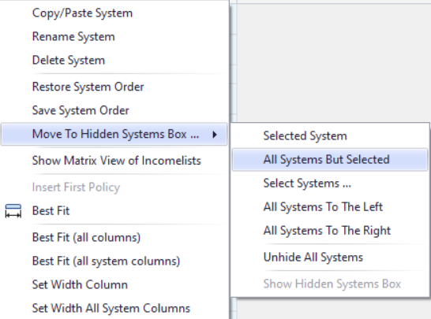

Add new system from UK_BI. Right-click on the system heading UK_BI and select the option ‘copy/paste system’. Specify a name for the reform system (type e.g. UK_BIref1).

Figure 2: Adding a reform system using the copy/paste option

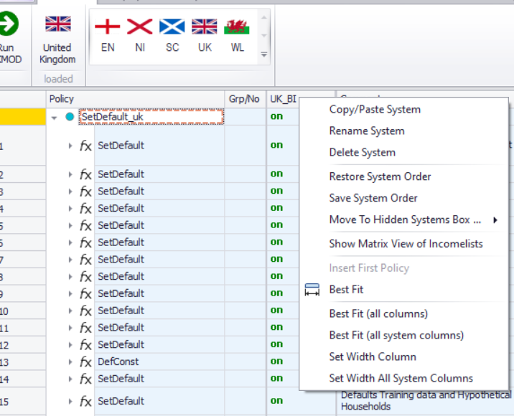

Figure 3: Giving a name to the reform system

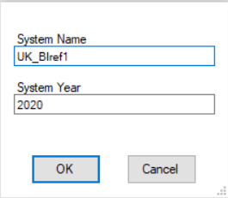

Step 2: Implementing the reform
You need to remove Basic Income from the income lists that define taxable income. These are defined under ILDef_UK group, in the Tax Base before deducting allowances (il_tinty), and Gross NSND income (il_tinty_NSND) (non-savings and non-dividends income).

Figure 4: IL_Def_UK, Tax base before deducting allowances (il_tinty)

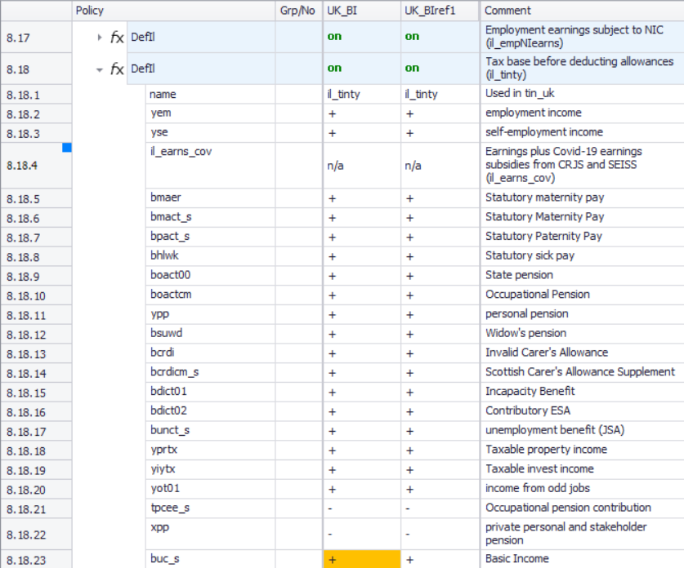

You need to remove buc_s from this list. Set it to n/a.

Figure 5: Setting buc_s to n/a in il_tinty

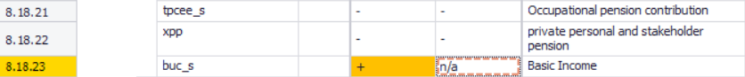

Do the same for the income list Gross NSND income (il_tinty_NSND)

Figure 6: Setting buc_s to n/a in il_tinty_NSND

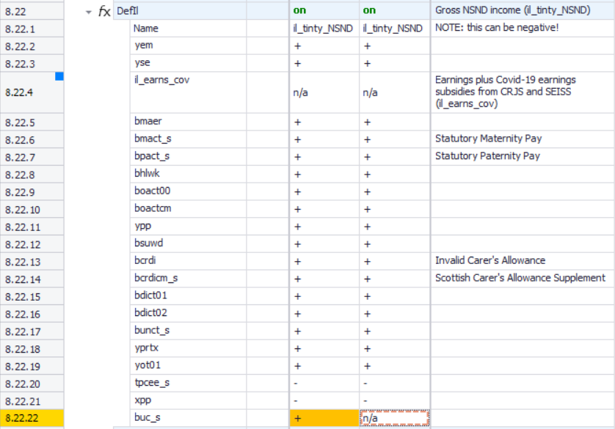

The next step is to go to the Basic Income policy buc_uk and make sure that the gross level of BI is the same as the net BI.

The net BI is defined under ConstDef_UK in $_netBI (for working-age adults) and $_netpens (for pensioners):

Figure 7: Constants for net BI

Make a note of the name of these two constants.

Then go to the buc_uk policy. In the functions that set gross levels of Basic Income, change the formula to the respective constant name: $_netBI for gross level of Basic Income (line 29.3.1), and $_netpens for gross level of BI for pensioners (line 29.8.1). On line 29.6, the formula should be changed to equal i_BI.

Figure 8: Change formula for calculating gross BI to name of respective constant (working-age)

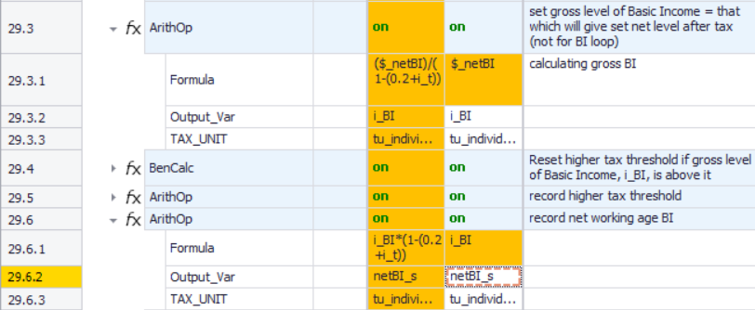

Figure 9: Change formula for calculating gross BI to name of respective constant (pensioners)

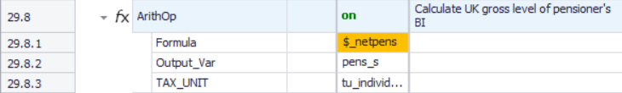

The final step is to turn off the functions that adjust the higher rate threshold if gross BI gets above it – not relevant if BI not taxed anyway. You right-click on the ‘on’ cells in lines 29.4 and 29.5 and choose ‘off’.

Figure 10: Turn off functions to do with differences between gross and net BI

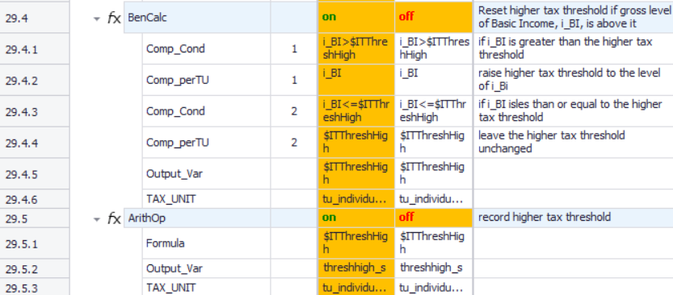

Remember: only make changes in the reform system!

Save your changes.

Step 3: Produce and analyse the micro-data output
Run the model to produce micro-data output for the baseline and reform system. Use the Statistics Presenter – option Baseline/Reform – to analyse differences in government revenues due to the changes in tax base.

Figure 11: Producing micro-data output for the baseline and reform systems

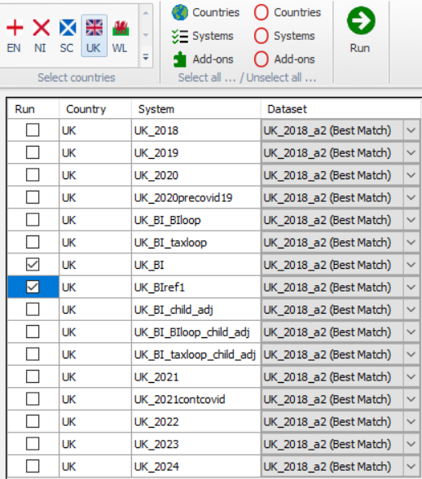

Figure 12: Opening Statistics Presenter – Baseline/Reform option

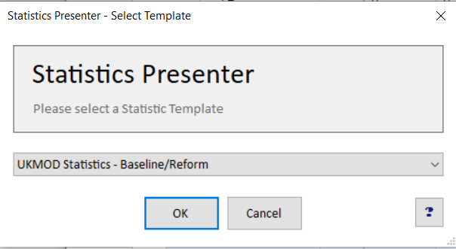

Figure 13: Selecting the relevant output files with the Statistics Presenter

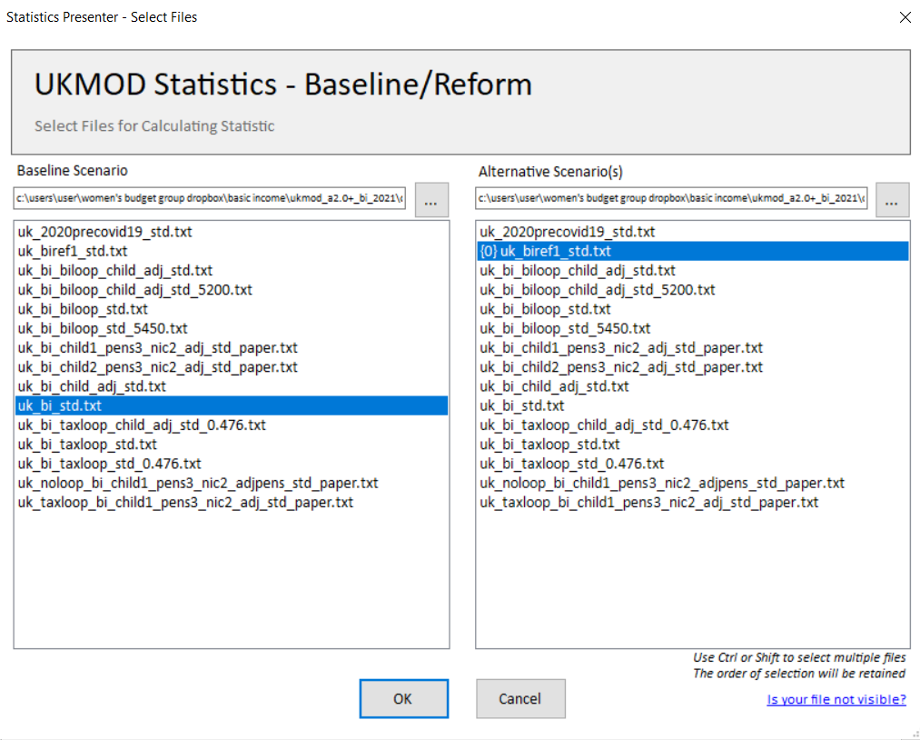

Solution
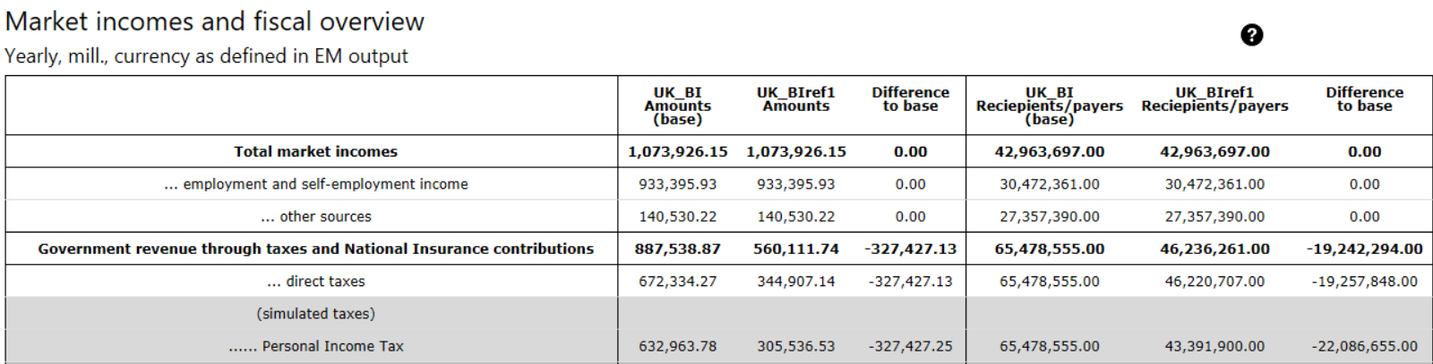

To note: fewer tax payers (everyone was one when Basic Income was taxable) and less revenue from personal income tax.
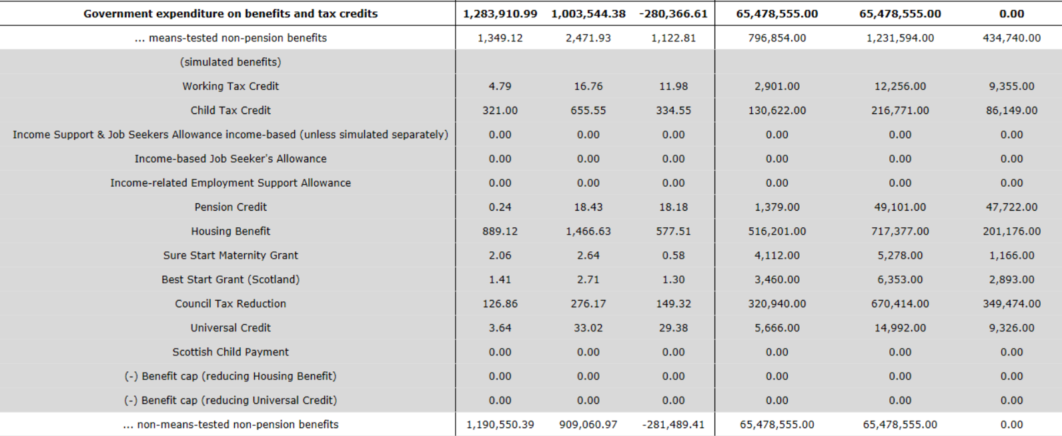

To note: higher spending on means-tested benefits because more people qualify for them, since their gross income is lower. Spending on non means-tested benefits (BI) is lower in reform system because the gross amount paid out as BI is less.

