DRUG CALCULATIONS 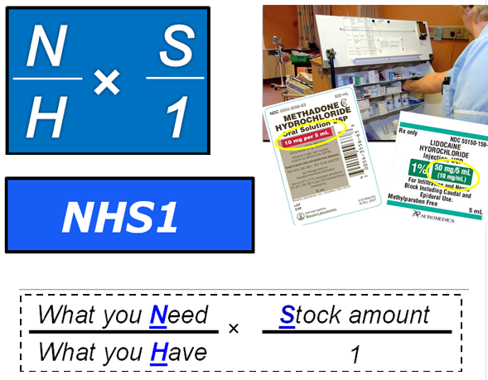
Very
Rarely
Troubled!

IV FLOW RATES (mls/hr)
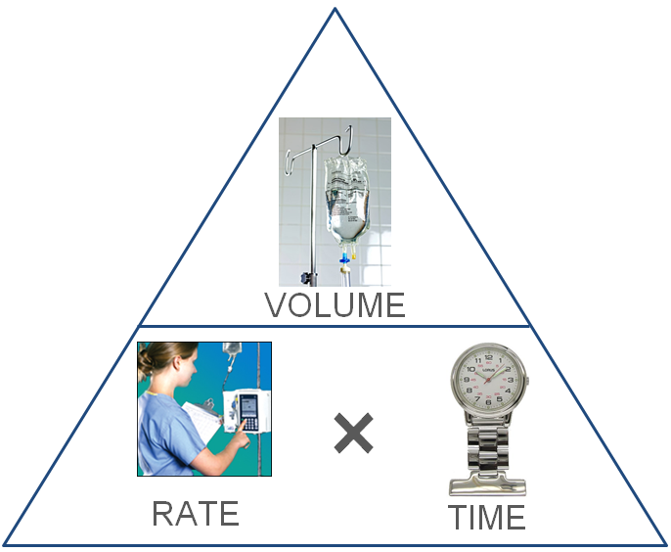
Use the triangle to cover up the missing element- you will be left with the correct formula.
Rate (ml/hr) = Volume (ml) ÷ Time (hrs)
Time (hrs) = Volume (ml) ÷ Rate (ml/hr)
Volume (ml) = Rate (ml/hr) × Time (hrs)

(hrs)
(mls)
IV DRIP RATES (drops/min)

Drip Rate (drops/min) = $\frac{Volume (mls)}{Time (mins)}$ × $\frac{Drop Factor (\text{drops/ml})}{1}$

Time (mins) = $\frac{Volume (mls)}{Drip Rate \text{(drops/min)}}$ × $\frac{Drop Factor (\text{drops/ml})}{1}$

Volume (mls) = $\frac{Drip Rate \text{(drops/min)}× Time (mins)}{Drop Factor (\text{drops/ml})}$

