Medicines Management Year 3
HS563: Exam Workshop (Calculations)
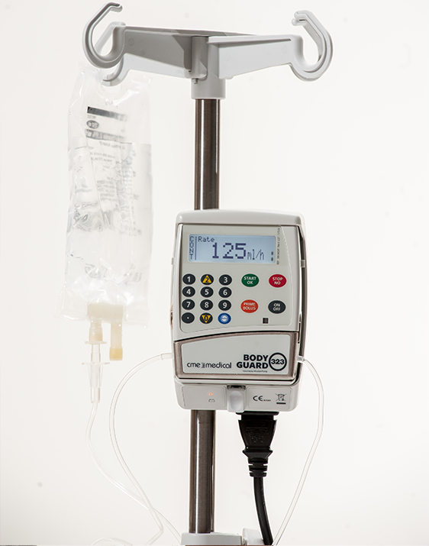


Tuesday 17 November, 2015

Contents:

The Ladder to Successful Nursing 3

Unit Conversions 4 – 7

Formulae: NHS1 8

Formulae: VRT 9

Formulae: VTDF 10

Practice Questions: Unit Conversions 11

Practice Questions: Tablets and Capsules 12

Practice Questions: Liquid Medicines & Injections 13

Practice Questions: IV Flow and Drip Rates 14

Practice Questions: Complex Calculations 15

ANSWERS: Available on the Numeracy Moodle Page – Section ‘Year 3: Practise Your Drug Calculations’

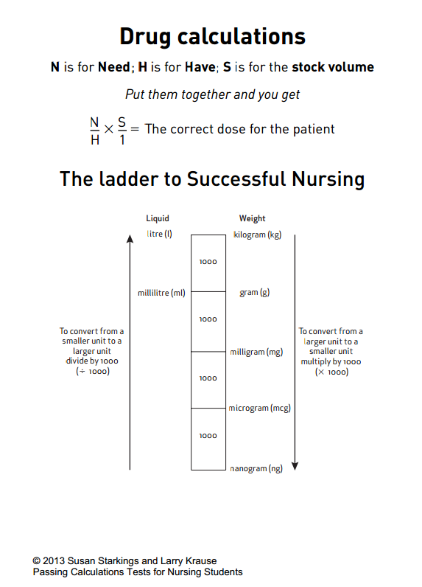
Unit Conversions
Converting a smaller unit into a larger unit

Convert 4 micrograms to milligrams
1) Identify the calculation. In this case, we need to divide 4 by 1,000

2) Write down your original number and add the decimal point and some ‘trailing zeros’.

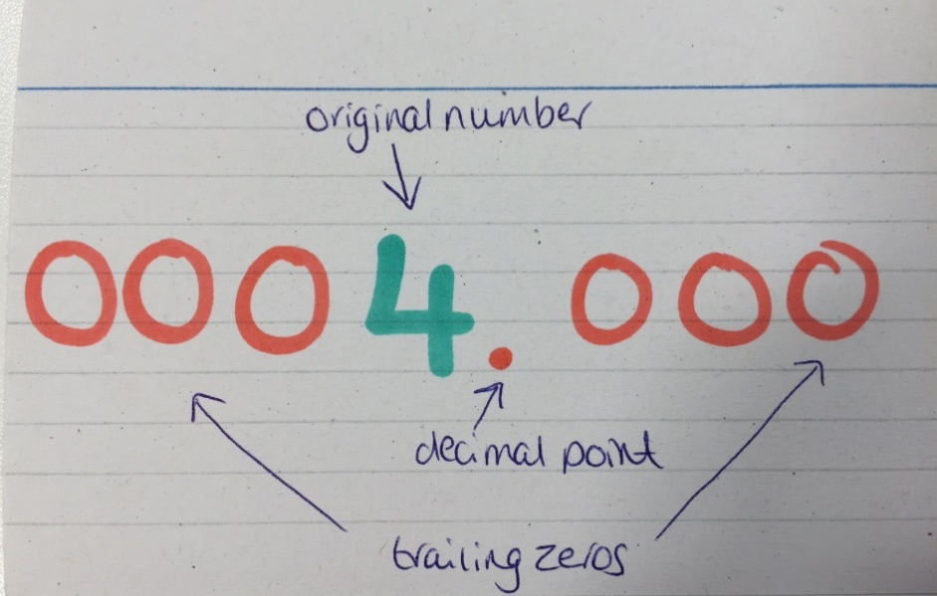
3) Move the decimal point 3 spaces to the left.

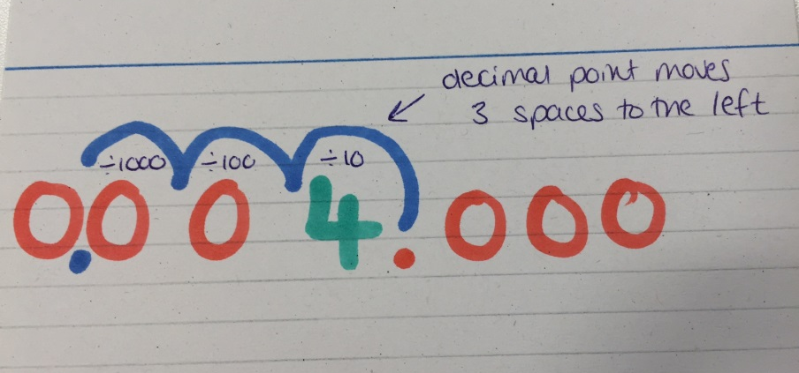
4) Extract the new number. This is your answer.

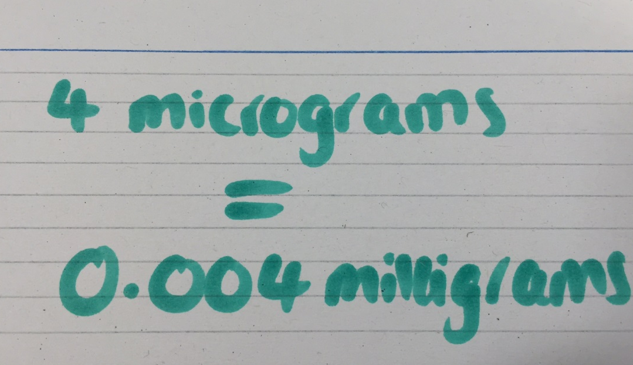
Converting a larger unit into a smaller unit
Convert 0.075 milligrams to micrograms
1) Identify the calculation. In this case, we need to multiply 0.075 by 1,000
2) Write down your original number and add the decimal point and some ‘trailing zeros’
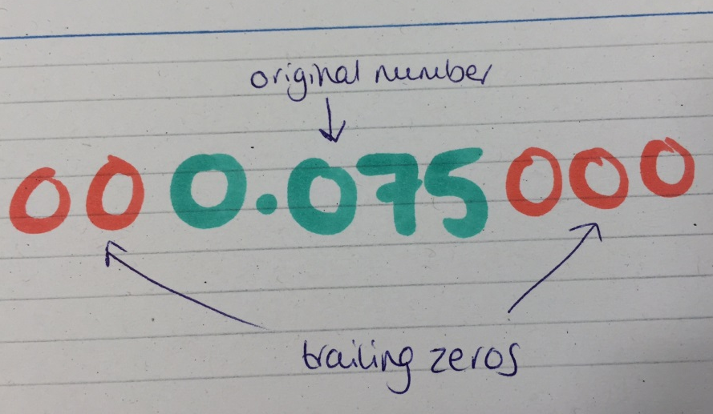
3) Move the decimal point 3 spaces to the right
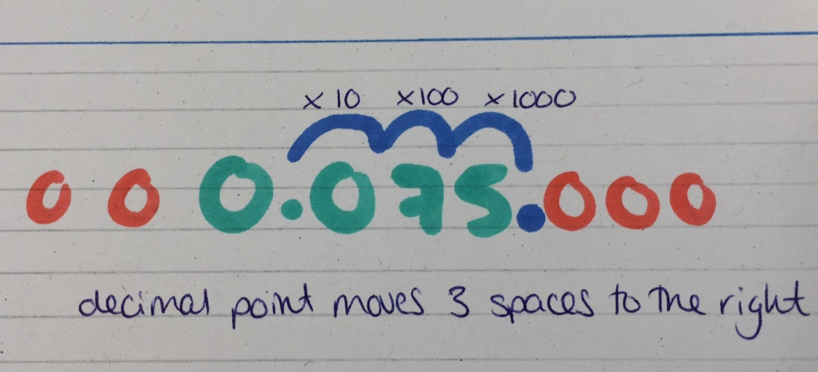
4) Extract the new number. This is your answer! 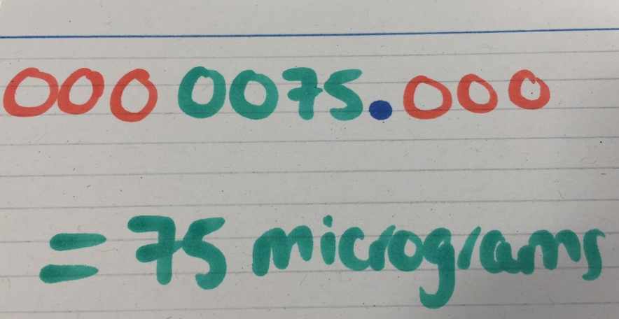
How to deal with the zeros
If we convert 30 micrograms to milligrams using the ‘moving the decimal point’ method, our written calculation will probably go through the following stages:

1) 30 micrograms

2) 00030.000 (add trailing and leading zeros)

3) 00.030 000 (move the decimal point)

4) Identify which zeros are necessary
Trailing zeros – must be removed
Additional leading zeros – must be removed
00.030000

Placeholder zero – affects the value of the 3 – ESSENTIAL!
One leading zero before the decimal point is essential for numbers less than 1 (BNF 2015).

5) Final answer: 0.03 milligrams
A final word about units…
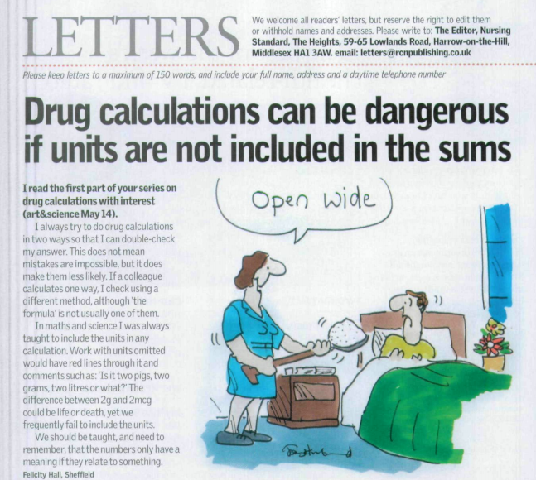
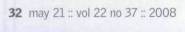

Exam Guidance
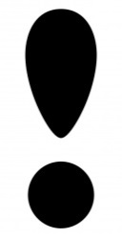
Warning!
You must clearly state the unit of measurement in your answer. The answer of 200 would not be correct, as this does not state whether this is units, grams or sack loads of the drug! (Wright 2011:23)

N.B. Incorrect units (e.g. writing mg instead of ml) or decimal points e.g. (0,3 instead of 0.3) will lose you the whole mark for the question, even if the numerical value is correct.

Standard formulae are available for calculating drug and IV medication doses. You need to know what they are and how to apply them.

- Tablets, Capsules, Liquid Medicines and Injections – NHS1

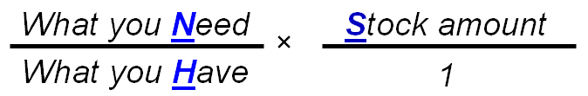
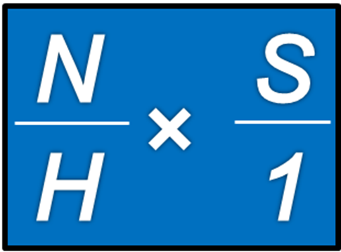
Have
Stock
1
Need
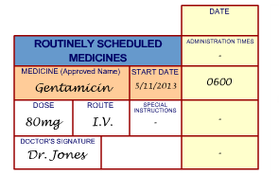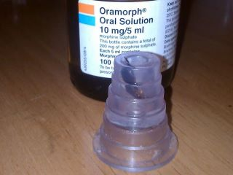
Oramorph
30mg

- IV Flow Rates in ml/hr – VRT

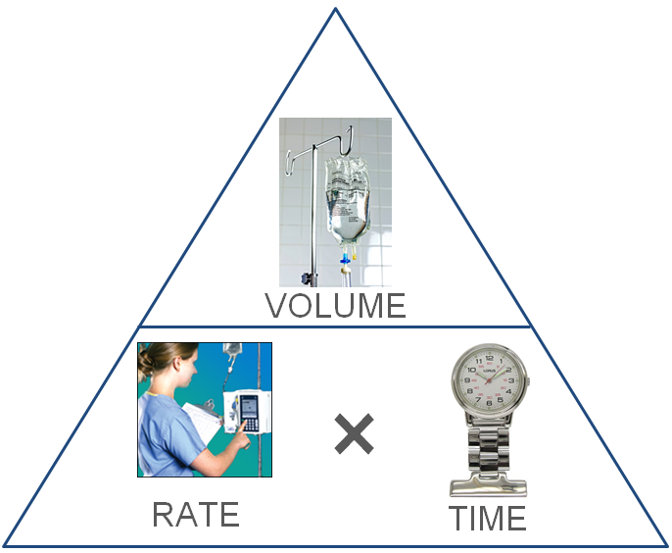

There are three elements to a flow rate calculation:

Volume – the amount of fluid to be delivered
Rate – the flow rate in ml/hr
Time – the amount of time taken

Use the triangle to cover up the element that you are trying to work out – you will be left with the correct formula.
Rate (ml/hr) = Volume (ml) ÷ Time (hrs)
Time (hrs) = Volume (ml) ÷ Rate (ml/hr)
Volume (ml) = Rate (ml/hr) × Time (hrs)

Remember – the fluid bag is high up!

The mnemonic Very Rarely Troubled may also help you to remember the formula.

3. Drip Rate Calculations in Drops/min (V/T*DF)

This is our basic formula for calculating a drip rate in drops/min. It is a Very Tidy Drip Formula!
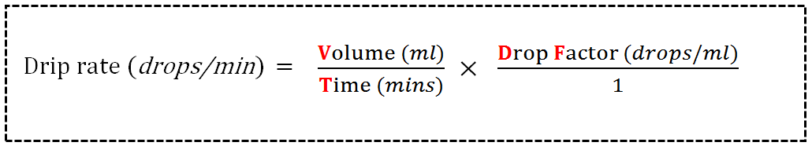

Like VRT, you can rearrange this formula to calculate the other elements. Below are the two variations for tackling time and volume calculations.

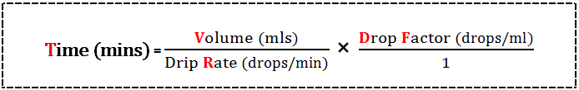

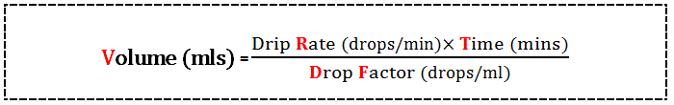

Note the similarities with the VRT set up; this will help you to memorise the variations. All you need to remember is where to embed the Drop Factor element.

Also, note the structural similarity with the NHS1 formula. Cancelling down the ‘fractions’, then multiplying across top and bottom works here too!

Calculating Drop Factors is not required. However, it is expected that you will be familiar with these.
UNIT CONVERSIONS

1. Convert the following quantities into milligrams:

a) 0.78 grams
b) 1025 micrograms
c) 0.02 grams
d) 0.007 grams

2. Convert the following quantities into grams:

a) 3675 milligrams
b) 7 milligrams
c) 25 milligrams
d) 40 milligrams

3. Convert the following quantities into micrograms:

a) 0.25 milligrams
b) 0.625 milligrams
c) 1.03 milligrams
d) 0.5 milligrams

4. Convert the following quantities into millilitres:

a) 2.4 litres
b) 0.75 litres
c) 0.03 litres
d) 0.567 litres

5. Convert the following quantities into litres:

a) 965 millilitres
b) 4 millilitres
c) 450 millilitres
d) 600 millilitres
As you approach registration, it is important that you begin to look beyond the arithmetic of calculating medication and other prescribed substances. This includes the expectation that you will be able to identify and minimise risks to patients, clients, friends and colleagues. The interests and safety of patients and clients must always be your first consideration (University of Dundee 2010).

The Medication Calculations section of the exam will test more than your ability to use formulae to calculate dosages. You will need to be prepared to apply the principles of administering medication in accordance with the Standards for Medicines Management (NMC 2007), including deciding whether to administer a prescribed substance or not, with reasons for your decision.

TABLETS AND CAPSULES

- Ruby has been prescribed tramadol 100 mg four times a day. On hand are 50 mg capsules; how many are needed for each dose?

- How much tramadol does Ruby take each day? You may give your answer in grams or milligrams.

- Illia has been prescribed 1 g metformin three times a day. On hand are 500 mg tablets; how many are needed for each dose?

- Janka has been prescribed 150 mg metoprolol once a day for heart failure. On hand are 100 mg scored tablets; how many are needed for each dose?

- Emma is prescribed erythromycin 50mg/kg/day in four daily doses. She weighs 80kg. Tablets on hand are 500mg. How many tablets do you give at each dose?

- Thandie is prescribed 20mg/kg/day of chloramphenicol in three daily doses. She weighs 75kg. How many 250 mg tablets do you give at each dose?

ANSWERS TO ALL QUESTIONS ARE AVAILABLE ON THE NUMERACY MOODLE PAGE IN THE SECTION ‘YEAR 3: PRACTISE YOUR DRUG CALCULATIONS’
Liquid Medicines

- You need to give 120 mg of furosemide orally. You have furosemide suspension 40 mg in 5mL. How much of the suspension do you need to give?

- If Oramorph® concentrate 100 mg/5 mL is used to give a dose of 80 mg for breakthrough pain, what volume is required?

- A patient with swallowing difficulties needs a dose of 400 mg of rifampicin. An oral solution is available at a strength of 100 mg/5mL. What volume of solution needs to be given for a dose of 400 mg?

- Obinze needs flucloxacillin 0.5g orally to treat a chest infection. Stock syrup on hand is 125 mg/5ml. What volume of syrup should you give to Obinze?

- A patient is ordered 600 mg of penicillin, orally. Stock mixture on hand has a strength of 250 mg/5 ml. What is the volume required?

- A phenytoin solution has a strength of 125 mg in 5 ml. A patient is written up for 150 mg. What volume is required?

Injections

- You have pethidine injection 100 mg in 2 mL. The patient is prescribed 75 mg. How much do you draw up?

- Stock vials of tramadol hydrochloride contain 100 mg in 2 ml. A patient requires 80 mg. How much is given?

- The strength of stock ampoules of morphine sulphate is 20mg/2ml. If the patient requires 15 mg, how much is given?

- Digoxin ampoules contain 0.5 milligrams in 2 ml. How much do you give if a patient is written up for 350 micrograms?

- A patient is prescribed penicillin 450 mg. On hand are stock ampoules containing 600 mg in 5 ml. How much is drawn up?
IV Infusions: Flow & Drip Rate Calculations

- What is the flow rate in mLs/hr if a patient is to receive a 240 mL infusion of normal saline over 3 hours?

- A patient needs 1 litre of a chemotherapy treatment, over 5 hours. What should the flow rate of the infusion pump be set at?

- A 500 mL infusion is running at a rate of 125 mL/hour. To the nearest whole number, how many hours is the infusion expected to run?

- A 1 L infusion is running at a rate of 83.3 mL/hour. To the nearest whole number, how many hours is the infusion expected to run?

- A patient is given an IV infusion of penicillin. The flow rate is set at 125 mL/hr. After 6 hrs, what volume has the patient received?

- Mr Brown is prescribed 500 mL of 5% dextrose to run over 6 hours using an IV infusion set that delivers 20 drops/mL. To the nearest whole number, how many drops/min should you set the infusion rate?

- A patient is prescribed 100 mL of 0.9% sodium chloride to run over 90 minutes using an IV infusion set that delivers 20 drops/mL. To the nearest whole number, how many drops/min should you set the infusion rate?

- Mr Ahmed is prescribed 1 unit of blood (350 mL) to run over 4 hours using an IV infusion set that delivers 15 drops/mL. To the nearest whole number, how many drops/min should you set the infusion rate?

- A patient is prescribed 500 mL of 5% dextrose to run over 4.5 hours using an IV infusion set that delivers 20 drops/mL. To the nearest whole number, how many drops/min should you set the infusion rate?

- A patient is prescribed 1 L of 0.9% sodium chloride to run over 7.5 hours using an IV infusion set that delivers 20 drops/mL. To the nearest whole number, how many drops/min should you set the infusion rate?

Complex Calculations

- Mr Houghton is prescribed 1 unit of blood (350 mL) to run at a rate of 45 drops/min using an IV infusion set that delivers 15 drops/mL. To the nearest whole number, how many hours is the infusion expected to run?

- A patient is prescribed 1 L of 5% dextrose to run at a rate of 42 drops/min using an IV infusion set that delivers 20 drops/mL. To the nearest whole number, how many hours is the infusion expected to run?

- A patient receives one litre of fluid IV at a rate of 40 drops/min for 3 hours. The drip chamber gives 15 drop/ml. After that time the remaining fluid is set to run over the next 8 hours. Calculate the drip rate for the last 8 hours.

/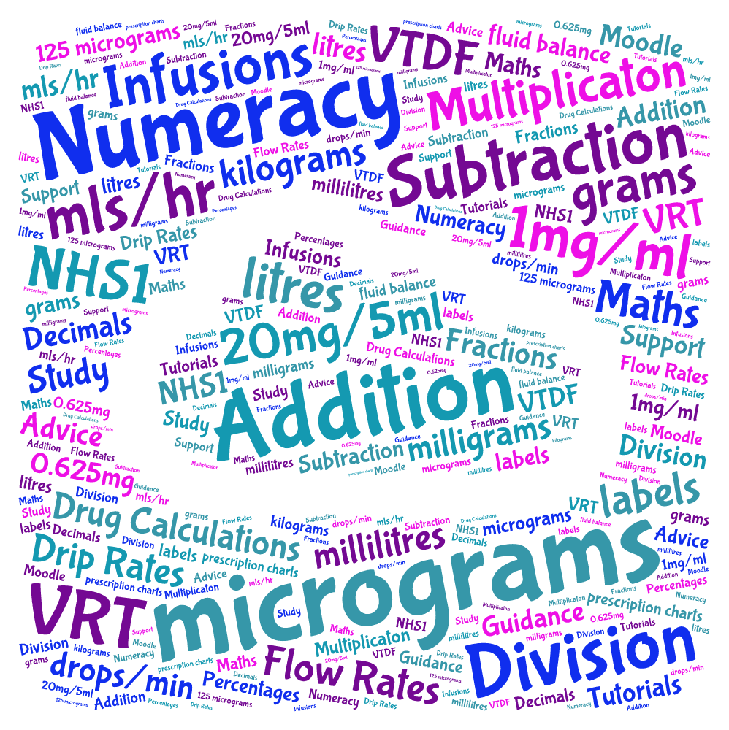

Still worried? Contact me to ask about extra support and resources:

Karen Hudson
Literacy, Language & Numeracy Tutor
School of Health and Human Sciences

T +44 (0)1702 328443
F +44 (0)1702 328359
E karen.hudson@essex.ac.uk

