Place Value Slide Rule – How It Works

We are going to use the slide rule to convert 0.250 milligrams to micrograms

1. Write 0250 on your slide rule strip and position it with the decimal point in the correct place:

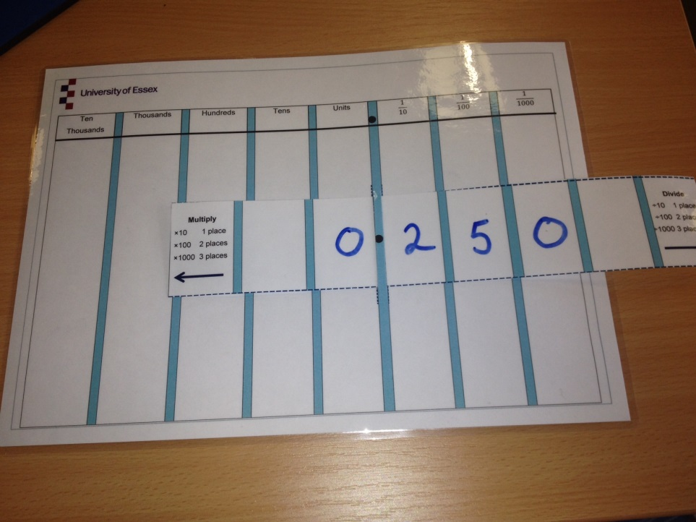

2. Decide which way we need to move the strip. In this instance, we need to multiply by 1,000. We therefore move the strip 3 places to the left, as indicated by the arrows.

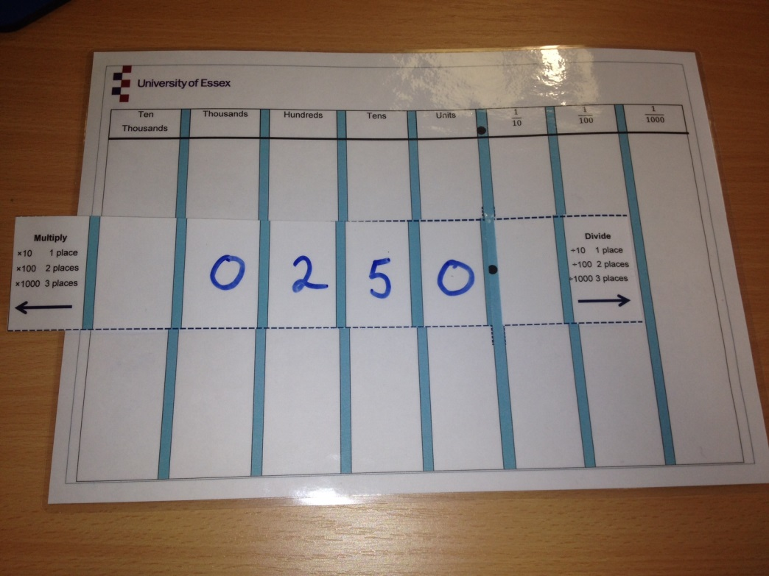

3. Read off the answer – 250 micrograms.

