**FLOW RATES (mls/hr)**

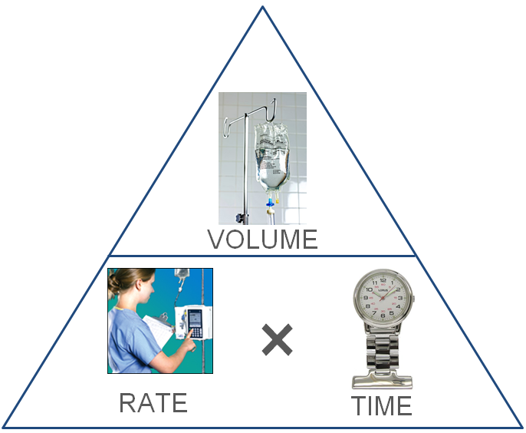

(mls)

(hrs)

**DRIP RATES (drops/min)**

**Drip Rate (drops/min) =** ×

**Time (mins) =** ×

**Volume (mls) =**