Numeracy for Nursing
Calculation Strategies 4: Division
There are several ways to approach division. The method that you have been taught will depend on where (and when!) you were last taught maths at school or college.

The aim of this guide is to reassure you that there are no ‘right’, ‘wrong’ or ‘better’ ways to get to the correct answer – only the way that works best for you! Other students will know and use different methods; this is absolutely fine as long as your own method works! Let’s look at some commonly used strategies:

- Repeated Halving  - Using a syringe as a number line  - Short Division | - Partitioning  - Using an easier starting point  - Space Saver Division

- Repeated Halving

Repeated Halving is a really useful basic strategy for solving straightforward division problems, particularly those involving doses for injection.

Example 1:

A drug is available as 20mg in 2ml. You need to administer 5mg. How many ml must you administer?
20mg in 2ml halve both sides
10mg in 1ml halve both sides again
5mg in 0.5ml

- Using a Syringe as a Number Line
It may be useful to use a syringe as a number line for division when you are working out straightforward drug calculations:

Example 2:

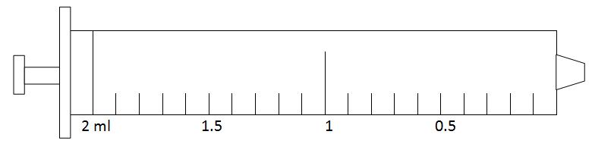
20mg = 2ml
10mg = 1ml
5mg = 0.5ml

20mg in 2ml halve both sides
10mg in 1ml halve both sides again
5mg in 0.5ml

- Partitioning (Chunking)

This method involves breaking the numbers down into easier ‘round number’ and ‘single digit’ calculations. A useful example is that of Digoxin tablets, which often come in 62.5 mcg units

Example 3: What is half of 125mcg?

125 mcg = 120 + 5
120 ÷ 2 = 60 5 ÷ 2 = 2.5

60 + 2.5 = 62.5 mcg
Therefore, half of 125 mcg is 62.5 mcg

- Using An Easier Starting Point

This is a variation on the theme of using numbers that are easier to work with.

Example 4:

54kg ÷ 6 = 60 ÷ 6 = 10
so, 54 ÷ 6 = 9kg

- Written Division

Before trying to learn methods for written division, it is a good idea to review and revise your times tables. A multiplication/division table is provided on the next page for you to print out and keep.

Good online screencast resources for long division can be found here:

http://www.qub.ac.uk/elearning/public/NumeracySkillsforDrugCalculations/Year1GenericSkillsTest/SimpleDivision/

https://www.khanacademy.org/math/arithmetic/multiplication-division/long_division/v/level-4-division

http://www.bbc.co.uk/skillswise/factsheet/ma12pape-l1-f-spacesaver-division

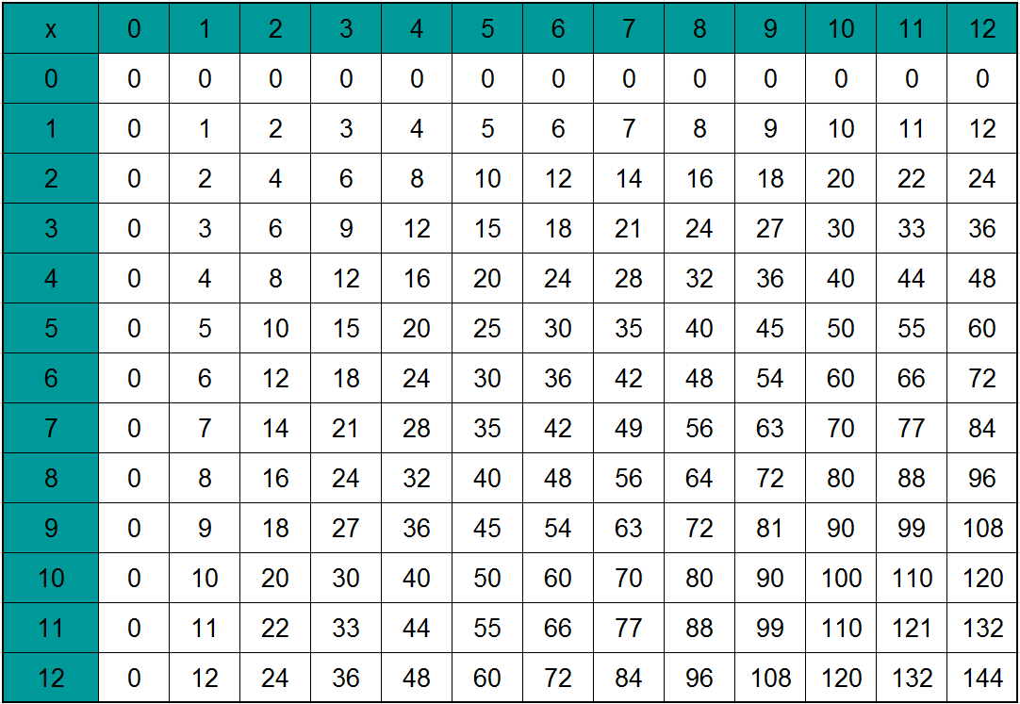
Multiplication Table

Dividing by Single Digits

Example 5:

A patient is to receive 1000ml of 0.9% sodium chloride solution over 8 hours. Calculate the flow rate in ml/hr.

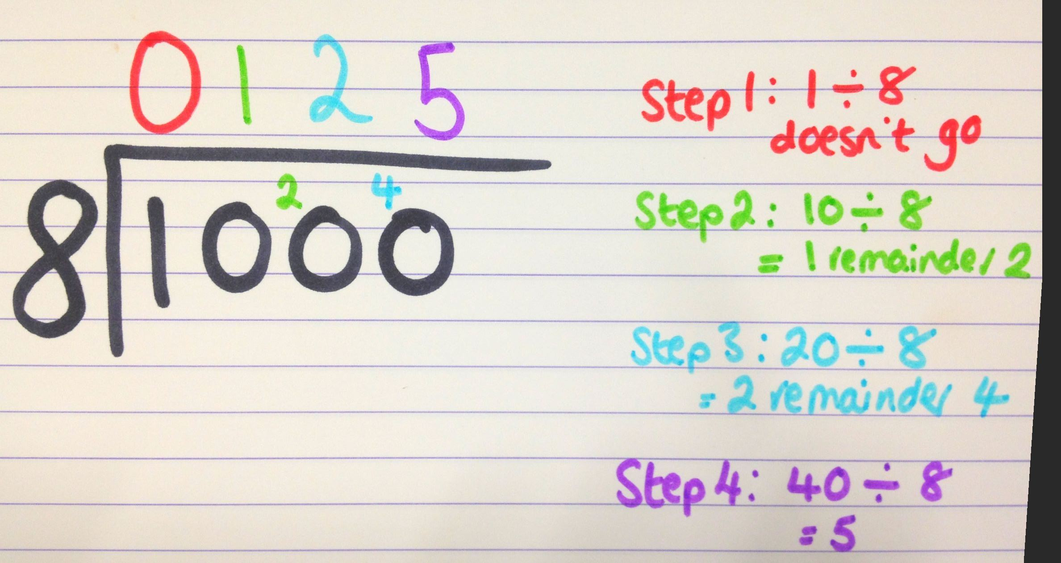

It is useful to note that there are several ways to notate a division calculation:

This calculation can be written as:

- 1000 ÷ 8

- 8 1000
- 1000 Note the visual similarity to the symbol for division!
8

Understanding that division calculations can also be written as fractions, and vice versa, will be very useful when starting to working with the formulae involved in drug calculations.

Space Saver Division

This method is a more straightforward alternative to long division when dividing by a 2-digit number.

Example 6:
A patient is to receive 1000ml of 0.9% sodium chloride solution over 12 hours. Calculate the flow rate in ml/hr.

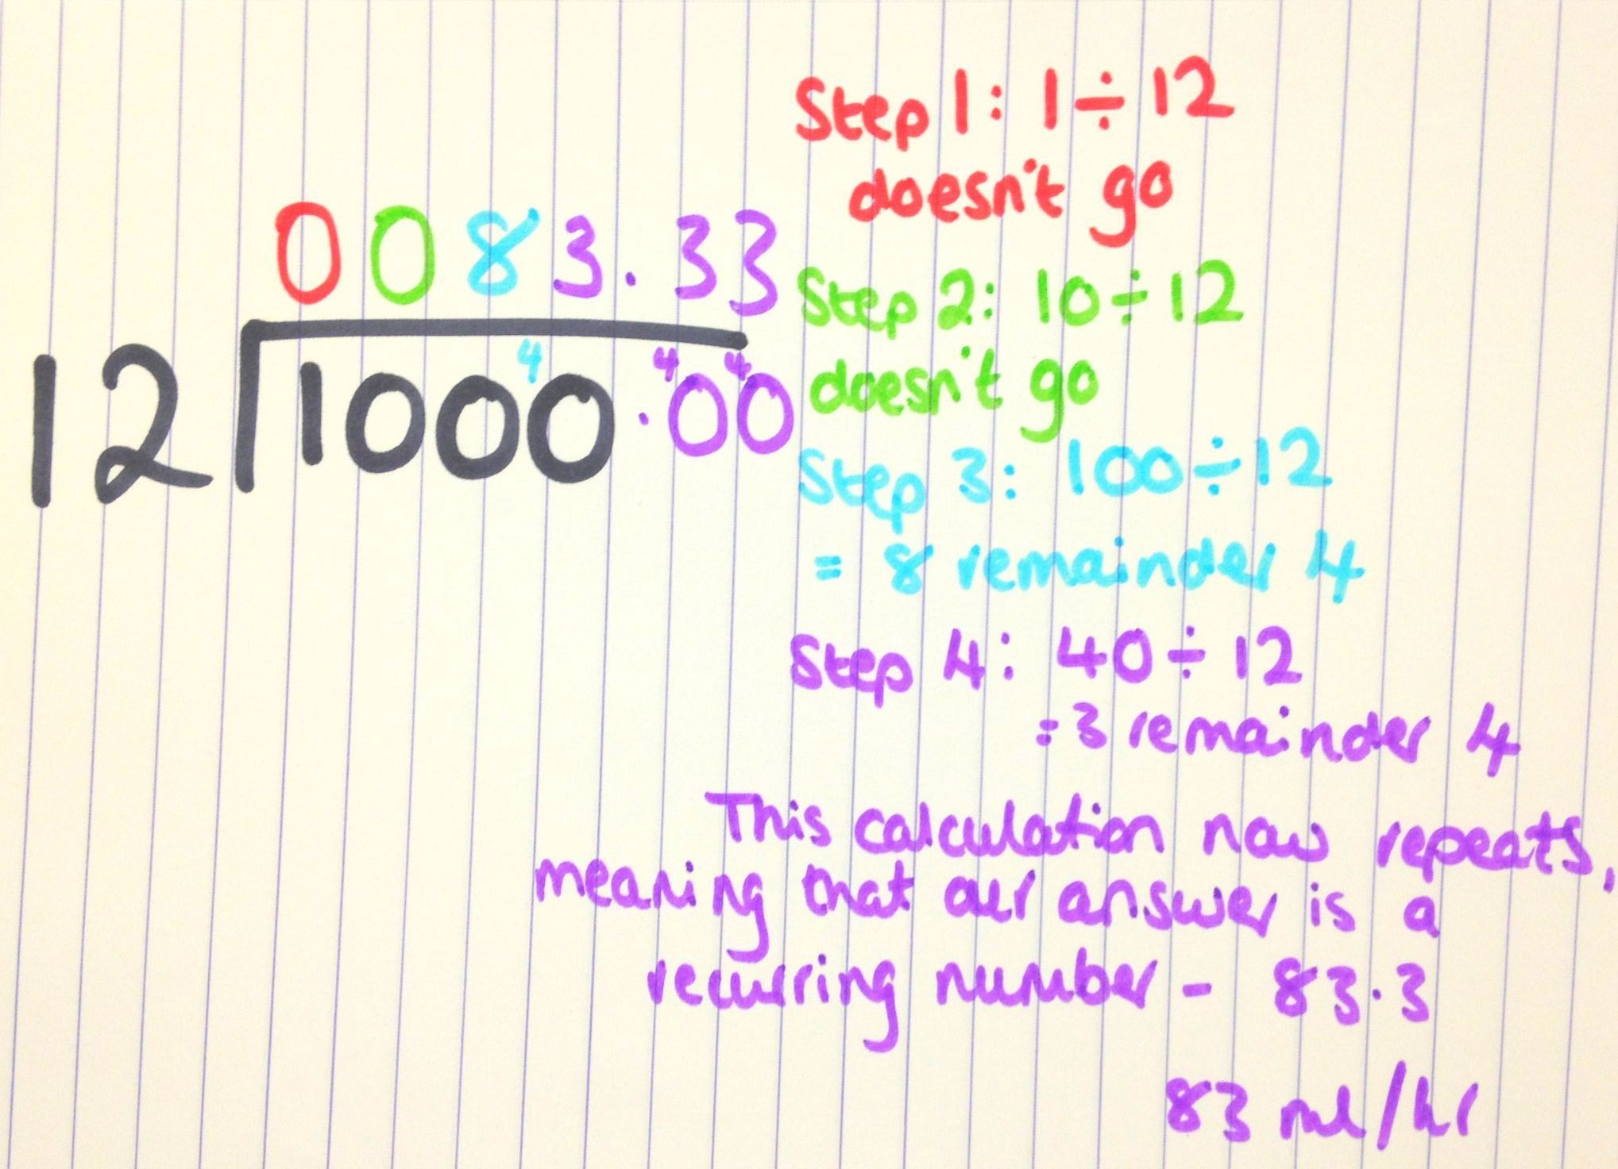

Alternatively, cancel down the problem using proportion:
1000 ÷ 12 is the same as 500 ÷ 6 is the same as 250 ÷ 3
You now have a single digit division to perform, which you may find easier.

