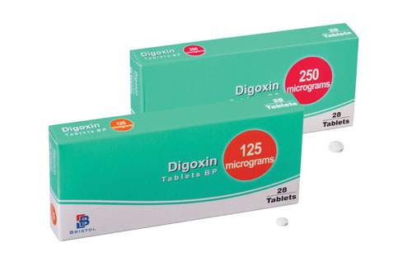
Working out a dosage from a label
- Digoxin

The strength of digoxin on product labels is often given in micrograms. However, you often find a patient's dose is written up on the medication chart in milligrams. You need to make sure you are using the same units when working out how much of the medication to administer. The table shows how the same amount can be written and read off in either micrograms or milligrams .

 | Grams | Milligrams |  |  | Micrograms
125 mcg |  |  |  |  | 1 | 2 | 5
0.125 mg |  |  |  | 0 | 1 | 2 | 5
250 mcg |  |  |  |  | 2 | 5 | 0
0.25 mg |  |  |  | 0 | 2 | 5

Worked example

A patient is prescribed 0.25 mg of digoxin orally. The tablets available are 125 micrograms. How many tablets should the patient receive?

Convert both amounts to micrograms 0.25 mg = 250 micrograms
Now insert both amounts into the formula -

What you need x stock volume
What you have

250 x 1 tablet
125

2 x 1 = 2 tablets 1

Now try this more difficult dosage question

A patient is prescribed 0.125 mg of digoxin orally. The tablets available are 62.5 micrograms. How many tablets should the patient receive?

