Numeracy for Nursing
Calculation Strategies 1: Addition
There are several ways to approach addition. The method that you have been taught will depend on where (and when!) you were last taught maths at school or college.

The aim of this guide is to reassure you that there are no ‘right’, ‘wrong’ or ‘better’ ways to get to the correct answer – only the way that works best for you! Other students will know and use different methods; this is absolutely fine as long as your own method works! Let’s look at some commonly used strategies:

- Counting On  - Partitioning and Recombining  - Using Near Numbers & Adjusting | - Using a Syringe as a Number Line  - Vertical Addition – Carrying  - Horizontal Addition – No Carrying

- Counting On

Counting on is a really useful basic strategy for solving addition problems. It simply means counting from a number other than 1

Example 1:

5 + 57 : Put the larger number first and count on: 57 + 5 = 62

Example 2:

Counting on by breaking into tens and units:

57 + 25 = 57 67 77 77 + 5 = 82
+10 +10
= +20

Using a syringe as a number line

It may be useful to use a syringe as a number line for counting on when you are working out straightforward drug calculations!

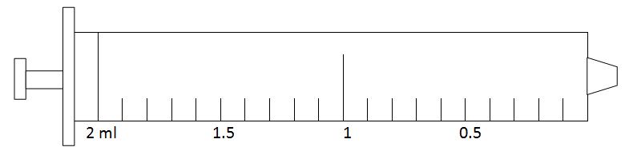

- Partitioning and Recombining

Partitioning - Breaking a problem down into numbers that are easier to work with
Recombining - Adding them back together again

Example 3:

378ml + 547ml 300 + 500 = 800
70 + 40 = 110
This is an example of the vertical method of addition
8 + 7 = 15
925ml
This is an example of the horizontal method of addition
800 + 110 = 910 910 + 15 = 925ml

- Using Near Numbers and Adjusting

This is a variation on the theme of using numbers that are easier to work with.

Example 4:

37 mg + 49 mg = 37 + 50 = 87mg
87 – 1 = 86mg

- Vertical Addition

This method will probably be very familiar from your memories of school maths lessons! It is also known as column addition. The screencasts will help to remind you of this method, which may involve carrying numbers over into the next column along.

Example 5:

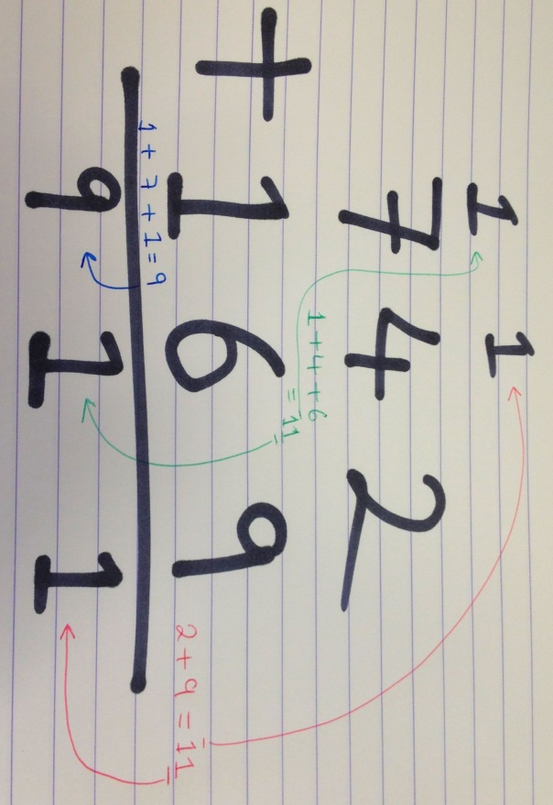

- Horizontal Addition

This method involves an element of partitioning and recombining. It is easily illustrated using a calculation involving money.

Example 6:
£1.56 + £3.72
- £1.00 + £3.00 = £4.00
- 50p + 70p = £1.20 (counting on in tens is useful here!)
- 6p = 2p = 8p
- £4.00 + £1.20 = £5.20 £5.20 + 8p = £5.28

