|  |
| --- |
| Numeracy for Nursing |
|  |
| Calculation Strategies 2: Subtraction |
|  |

There are several ways to approach subtraction. The method that you have been taught will depend on where (and when!) you were last taught maths at school or college.

The aim of this guide is to reassure you that there are no ‘right’, ‘wrong’ or ‘better’ ways to get to the correct answer – only the way that works best for you! Other students will know and use different methods; this is absolutely fine as long as your own method works! Let’s look at some commonly used strategies:

|  |  |
| --- | --- |
| * Counting On * Partitioning and Recombining * Using Near Numbers & Adjusting | * Vertical Subtraction – Borrowing * Horizontal Addition – No Carrying |

1. **Counting On**

Counting on is a really useful basic strategy for solving addition problems. It simply means counting from a number other than 1. Counting on in numbers larger than units (e.g. 2s, 4s, 10s) is known as **skip counting.**

**Example 1:**

23 - 18

Count on from the smaller number to the largest

i.e. from 18 to 23 = 5

**Example 2:**

Counting on by breaking into tens and units:

83 - 58 = 58 68 78 83 = 25

+10 +10 +5

= +25

1. **Partitioning and/or Recombining**

Partitioning -Breaking a problem down into numbers that are easier to work with

Recombining - Adding them back together again – this only applies when you have dealt with the hundreds, tens and units separately as show below:

**Example 3:**

988 ml – 432 ml 900 - 400 = 500

80 - 30 = 50

This is an example of the **vertical** method of ***addition***

8 - 2 = 6

**556ml**

This is an example of the **horizontal** method of sub**traction**

988 – 400 = 588 588 – 30 = 558 558 – 2 = **556ml**

1. **Using Near Numbers and Adjusting**

This is a variation on the theme of using numbers that are easier to work with.

**Example 4:**

43 mg - 19 mg = 43 - 20 = 23 mg

23 + 1 = **24mg**

1. **Vertical Subtraction**

This method will probably be very familiar from your memories of school maths lessons! It is also known as **column subtraction**. The Khan Academy screencast will help to remind you of this method, which may involve borrowing numbers from the next column along.

**Example 5:**

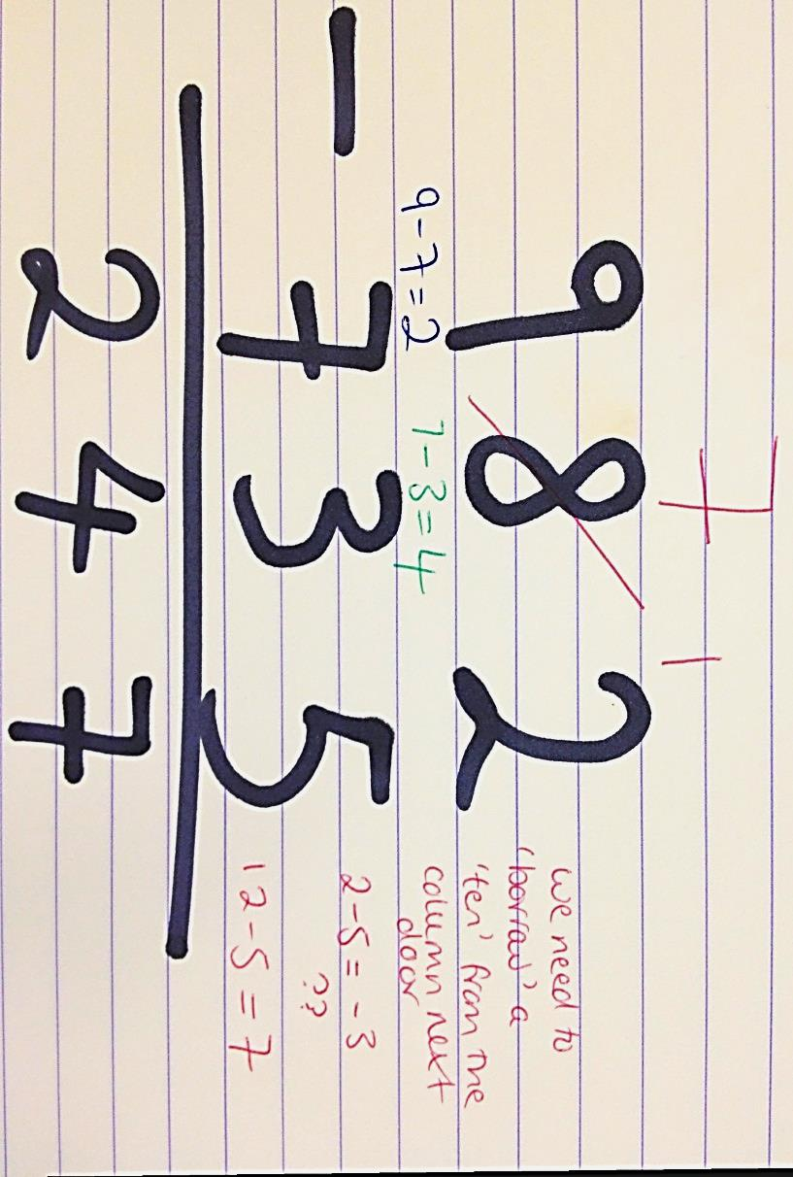

1. **Horizontal Addition**

This method involves an element of partitioning and recombining. It is easily illustrated using a calculation involving money.

**Example 6:**

£3.76 - £1.52

1. £3.00 - £1.00 = £2.00
2. 70p - 50p = 20p (skip counting in tens is useful here!)
3. 6p - 2p = 4p
4. £2.00 + 20p = £2.20 £2.20 + 4p **= £2.24**