**British values and Occupational Therapy**

**What are British Values?**

Fundamental British Values underpin what it is to be a citizen in a modern and diverse Great Britain valuing our community and celebrating diversity of the UK.

These values are **Democracy, Rule of Law, Respect** and **Tolerance, Individual Liberty.**

**Democracy**

A culture built upon freedom and equality, where everyone is aware of their rights and responsibilities. E.g.

* Leadership and accountability
* Joint decision making
* Team meetings
* The right to protest and petition
* Receiving and giving feedback

**Rule of Law**

The need for rules to make a happy, safe and secure environment to live and work. E.g.

* Legislation
* Agreed ways of working, policies and procedures
* How the law protects you and others
* Codes of conduct

**Respect and Tolerance**

Understanding that we all don’t share the same beliefs and values. Respecting the values, ideas and beliefs of others whilst not imposing our own others. E.g.

* Embracing diversity
* The importance of religion, traditions, cultural heritage and preferences
* Stereotyping, labelling and prejudice
* Tackling discrimination

**Individual Liberty**

Protection of your rights and the right of others you work with. E.g.

* Equality and Human Rights
* Personal Development
* Respect and Dignity
* Rights, choice, consent and individuality
* Values and principles

**RCOT values (RCOT, 2022)**

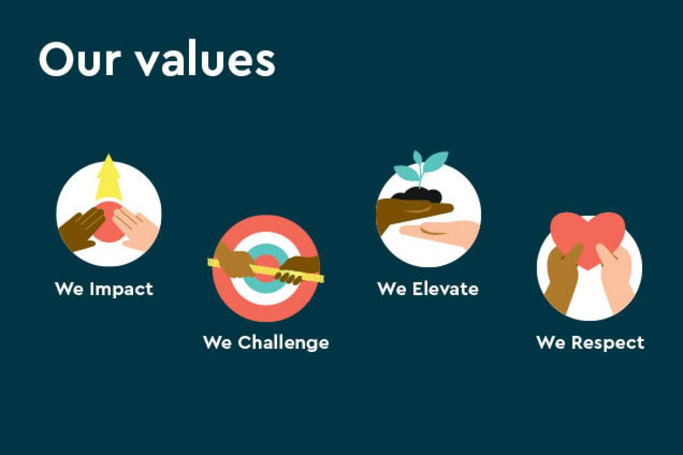

**We Impact**  
We make meaningful differences with all our work.  
We prioritise work that achieves our shared purpose and strategy.  
We go above and beyond for the people who need us.

**We Challenge**  
We find new and better ways to make things happen.  
We are brave and bold in our ideas and actions.  
We challenge ourselves, each other and the status quo.

**We Elevate**  
We lift up and support others to be and do their best.  
We are accessible and collaborative.  
We are united and move forward together, even if we sometimes disagree.

**We Respect**  
We value each other and celebrate our differences.  
We are approachable, genuine and trustworthy.  
We listen to others and believe everyone's views should be heard.

**Professional standards for occupational therapy practice, conduct and ethics (RCOT, 2021):**

<https://www.rcot.co.uk/publications/professional-standards-occupational-therapy-practice-conduct-and-ethics>

**Links between British values and OT values/standards:**

|  |  |
| --- | --- |
| **British values** | **Occupational therapy values/standards examples** |
| Democracy | Support others, united, believe everyone’s views should be heard, 5.7 – collaborative working |
| Rule of law | Code of Conduct, mental capacity legislation, record keeping, human rights, safeguarding vulnerable adults |
| Respect and tolerance | Move forward together even if we sometimes disagree, value each other and celebrate differences |
| Individual liberty | 3.3 – Diversity, equality and sensitivity, 3.4 – The importance of choice and personalised care, 5.2 – Equality and inclusion |