Numeracy for Nursing
Calculation Strategies 3: Multiplication
There are several ways to approach multiplication. The method that you have been taught will depend on where (and when!) you were last taught maths at school or college.

The aim of this guide is to reassure you that there are no ‘right’, ‘wrong’ or ‘better’ ways to get to the correct answer – only the way that works best for you! Other students will know and use different methods; this is absolutely fine as long as your own method works! Let’s look at some commonly used strategies:

- Repeated Doubling  - Partitioning and Doubling  - Using Near Numbers & Adjusting  - Long Multiplication | - Multiplying by 10 and Halving  - Multiplying by 10s, then by Units  - Written Multiplication

- Repeated Doubling

Repeated Doubling is a really useful basic strategy for solving straightforward multiplication problems, particularly those involving tablets or capsules.

Example 1:

4 x 25mg = 2 x 25 = 50
2 x 50 = 100mg

- Partitioning and Doubling

This method involves breaking the numbers down into easier ‘round number’ and ‘single digit’ calculations. A useful example is that of Digoxin tablets, which often come in 62.5 mcg units

Example 2:

2 x 62.5 mcg = 2 x 60 = 120
2 x 2.5 = 5
120 + 5 = 125 mcg

Therefore, 2 x 62.5 mcg digoxin tablets would provide a dose of 125 mcg.

- Using Near Numbers and Adjusting

This is a variation on the theme of using numbers that are easier to work with.

Example 3:

£2.89 x 4 = £3.00 x 4 = £12.00
(£3 – £2.89 = 11p) £12.00 – 44p = £11.56

- Multiplying by Ten and Halving

This is a very useful strategy when you need to multiply by 5.

Example 4:

5 x 14lb = 10 x 14 = 140
140 ÷ 2 = 70lb

- Multiplying by Tens, then by Units

Example 4:

21m x 13m = 21 x 10 = 210
This is another example of the vertical method of addition.
21 x 3 = 63
210 + 63 = 273m²

This method involves an element of partitioning and recombining. It can also be approached in a slightly different way, involving multiplying by ten and then doubling:

21m x 13m = 20 x 13 = 260 (10 x 13 = 130, then double it)
1 x 13 = 13
260 + 13 = 273m²

- Written Multiplication

Before trying to learn methods for written multiplication, it is a good idea to review and revise your times tables. A multiplication table is provided on the next page for you to print out and keep.

Good online screencast resources for long multiplication can be found here:

http://www.qub.ac.uk/elearning/public/NumeracySkillsforDrugCalculations/Year1GenericSkillsTest/Multiplication/

https://www.khanacademy.org/math/arithmetic/multiplication-division/multi_digit_multiplication/v/multiplication-6--multiple-digit-numbers

Multiplication Table
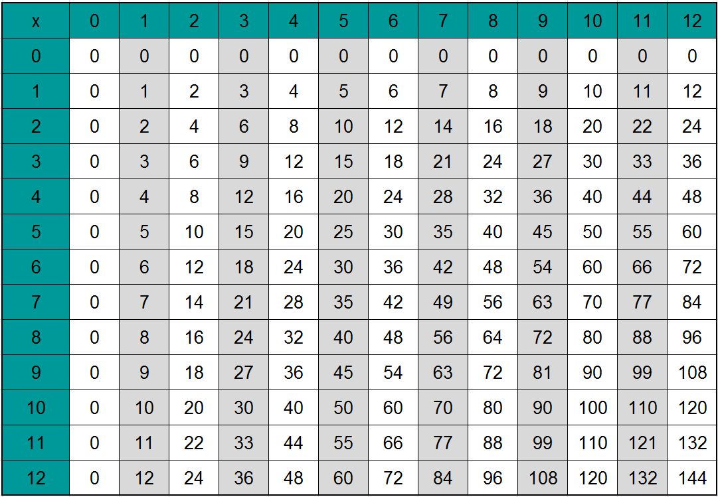

Multiplying 2 digits by 1 digit

Example 6:

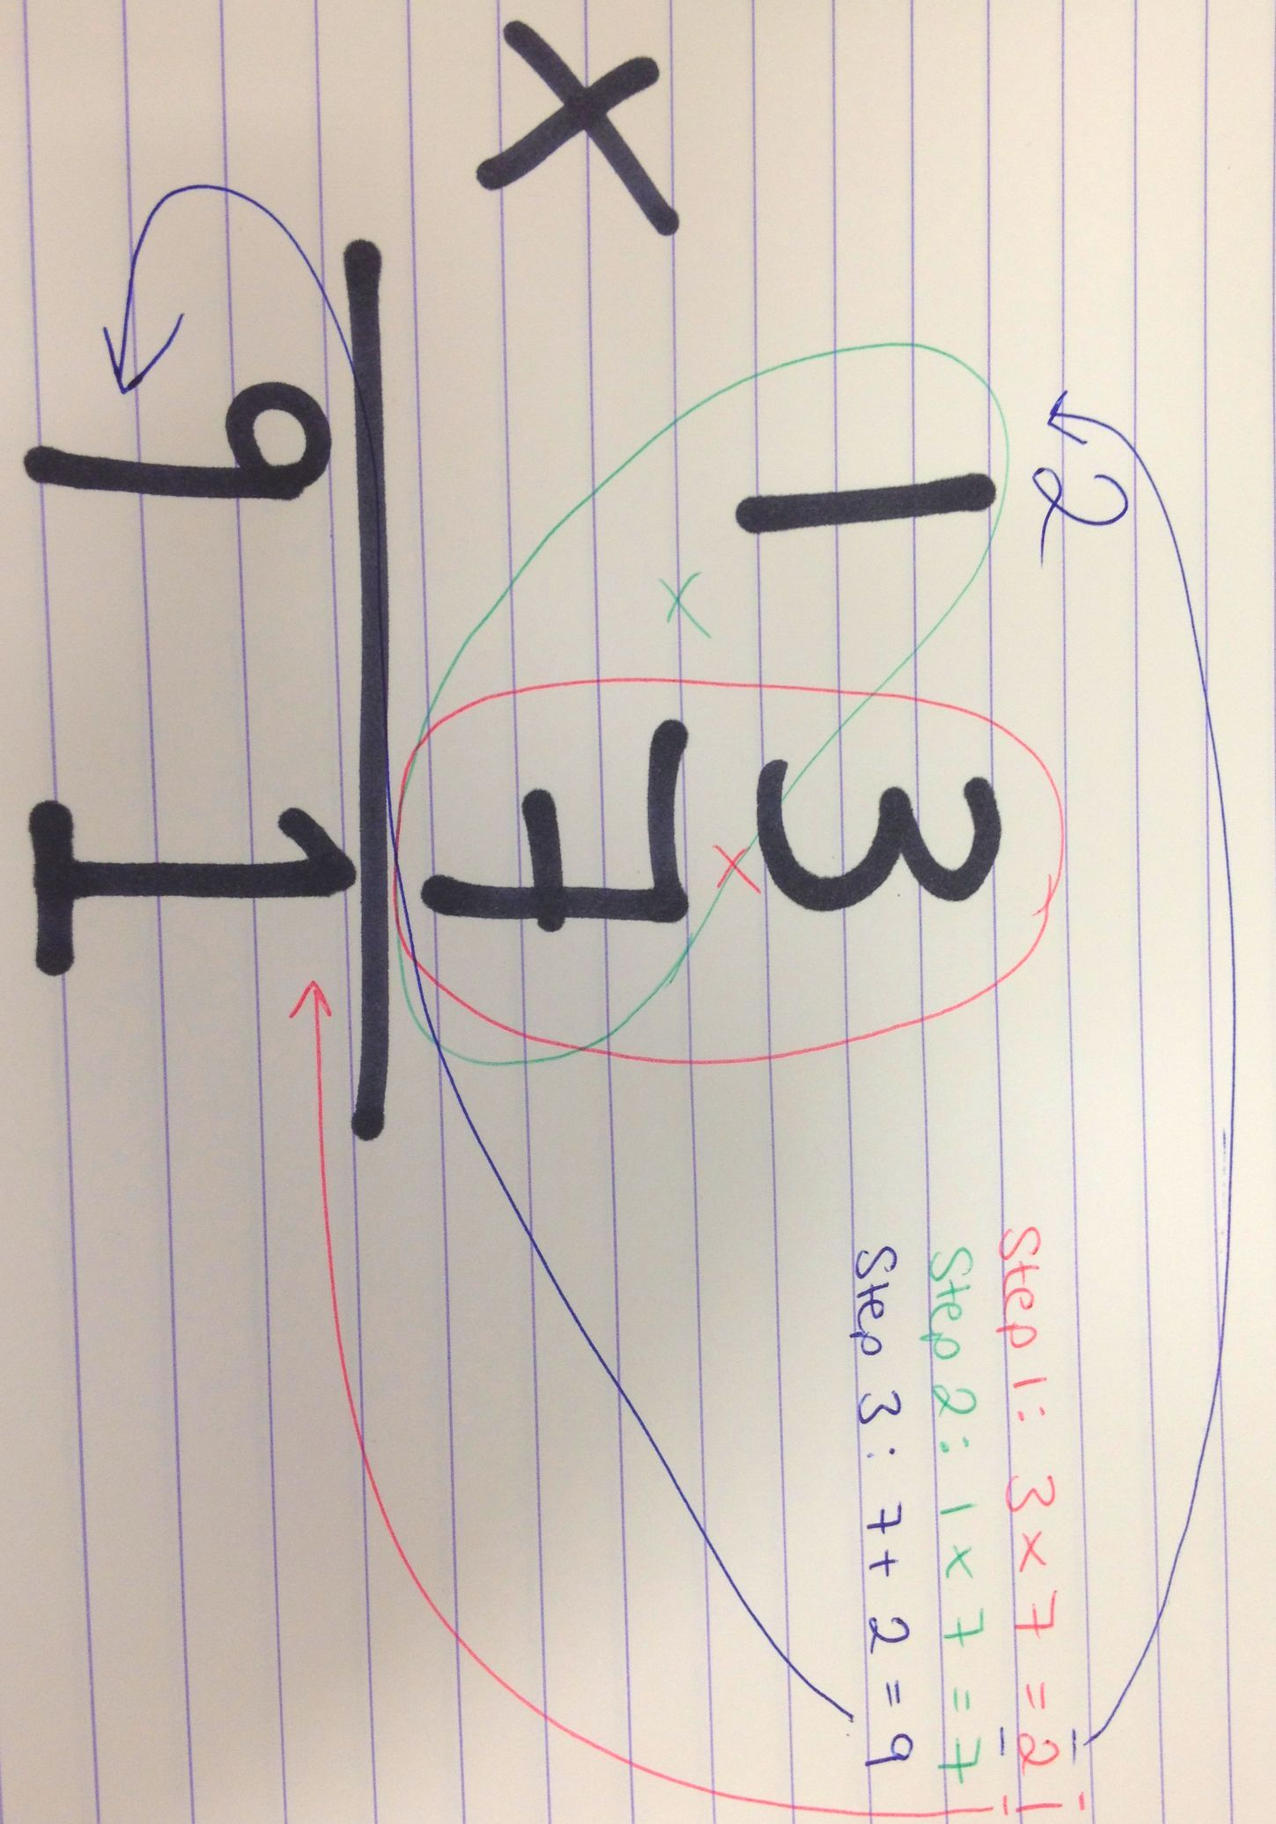

The Khan Academy Screencast will talk you through this method if you are still uncertain. An alternative approach might have been to break the calculation down into tens and units:

13 x 7 = 10 x 7 = 70
3 x 7 = 21
- + 21 = 91

Long Multiplication
Example 7:
- Firstly, write the sum correctly. This means placing units over units, tens over tens, etc.
54
x 72

- The first part of the calculation is done exactly as per Example 6 above:
Top Unit x Bottom Unit = 4x2 = 8
Top Tens x Bottom Unit = 5 x 2 = 10
54
x 72
108

- Then, because we are multiplying by ten, we need to write a 0 under the Units column and repeat the process, but with the Bottom Tens instead of the Bottom Unit.

Top Unit x Bottom Tens = 4x7 = 28
Top Tens x Bottom Tens = 5 x7 = 35
Add any carried over tens to the second stage = 35 + 2 = 37
2
54
x 72
108
3780

- Now use vertical addition to add the two numbers together. This is your final answer!
2
54
x 72
108
3780
3888

